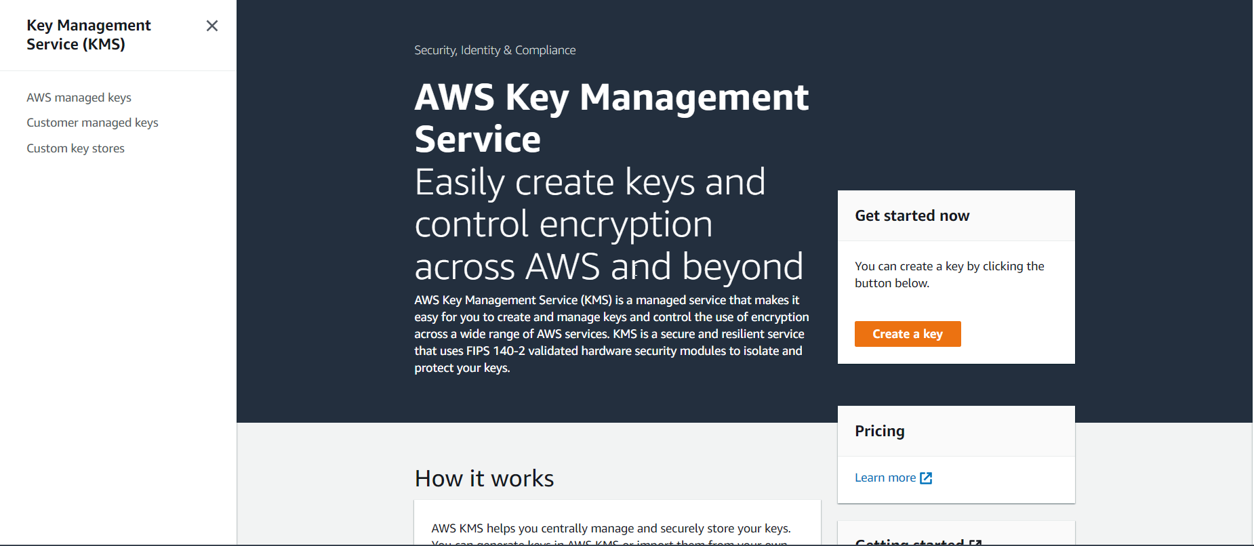

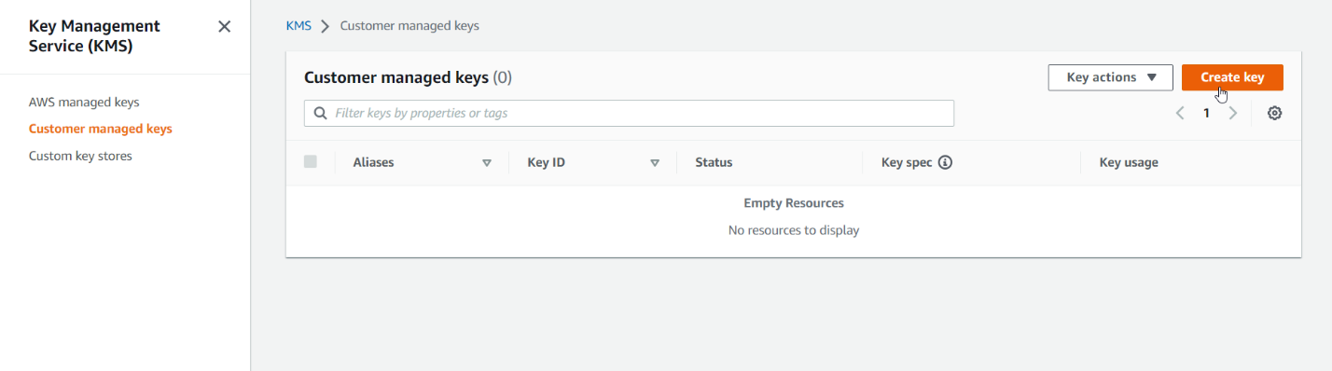

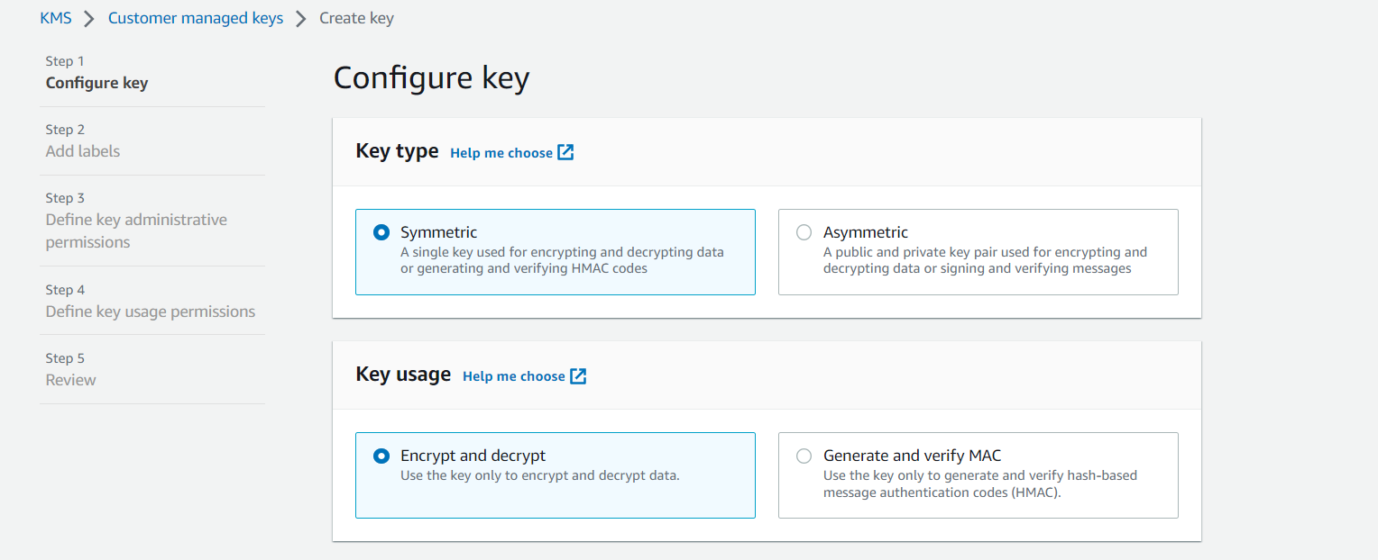

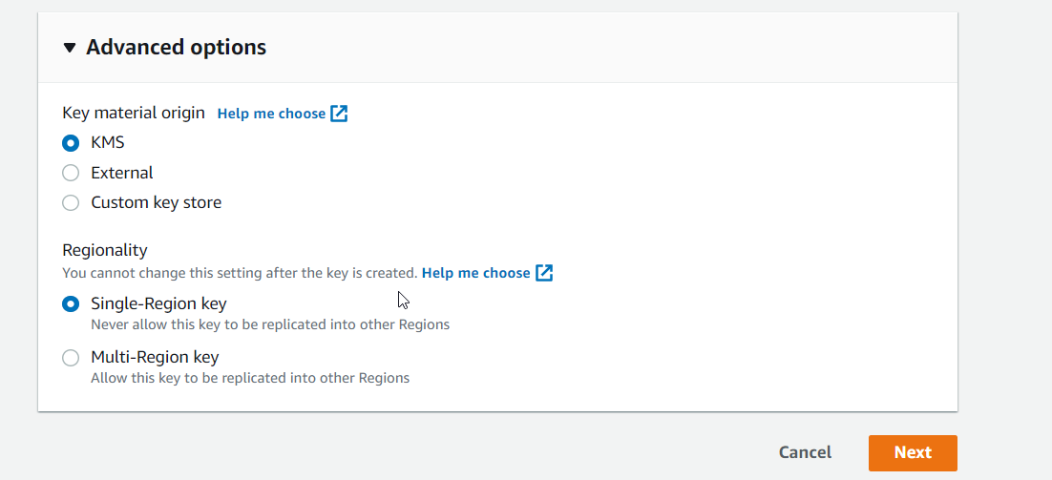

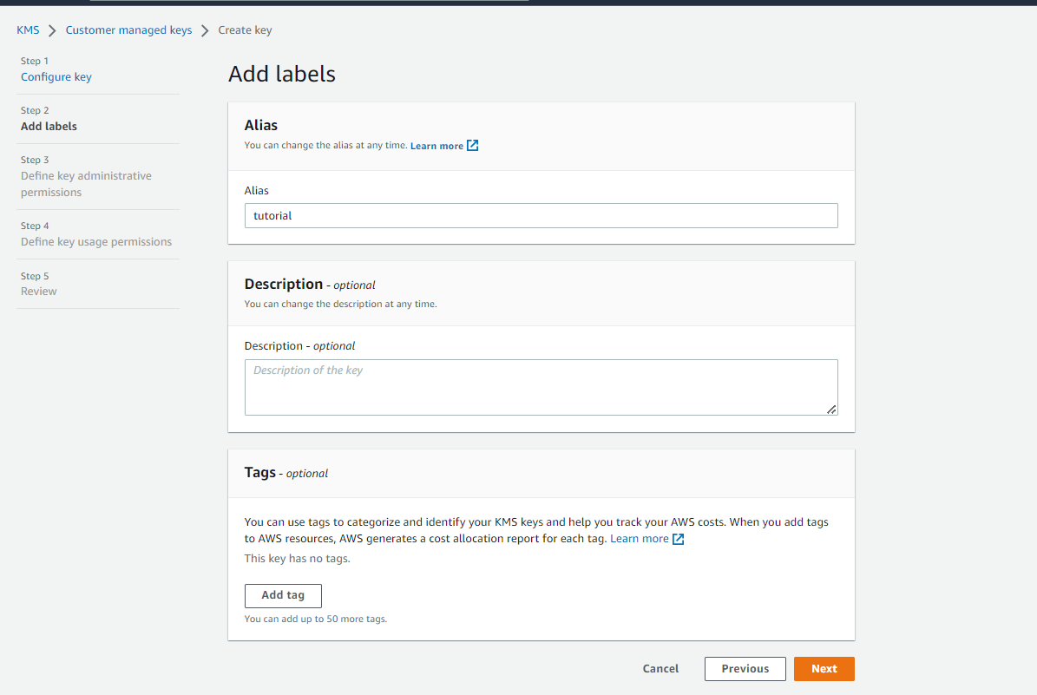

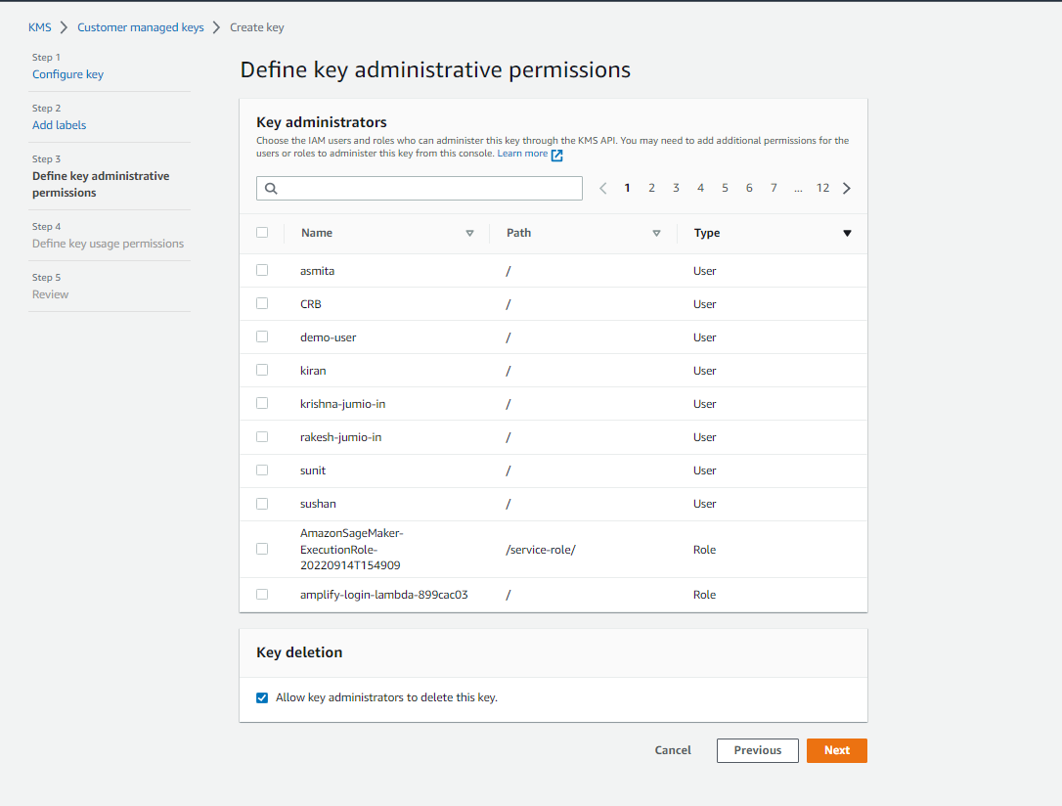

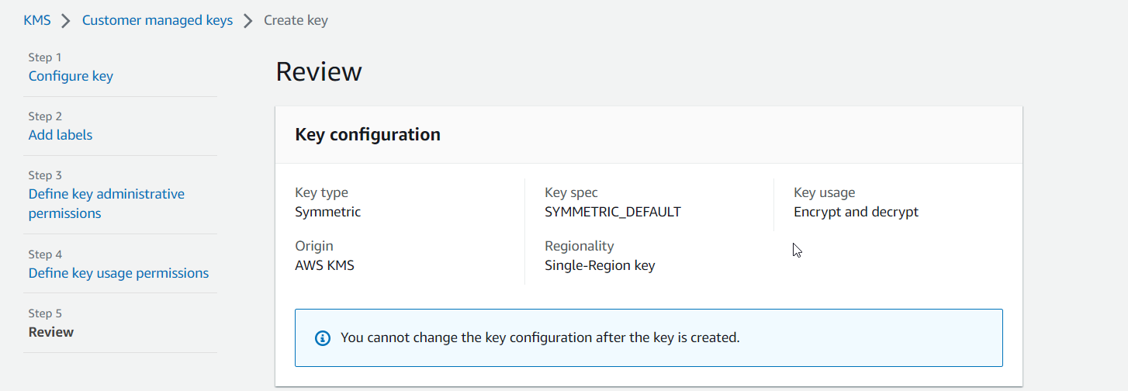

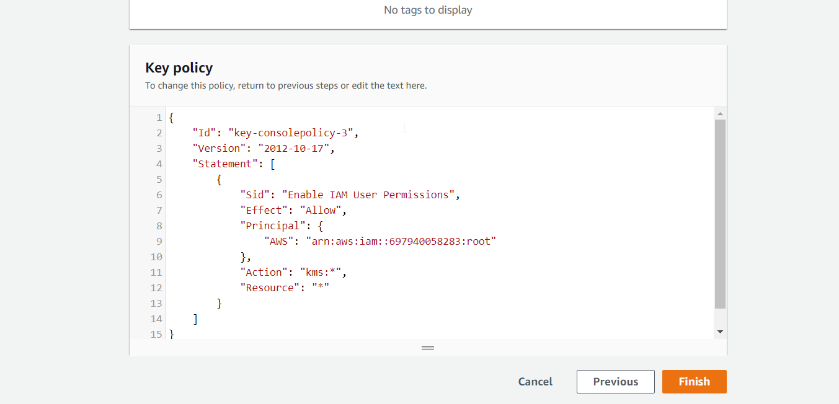

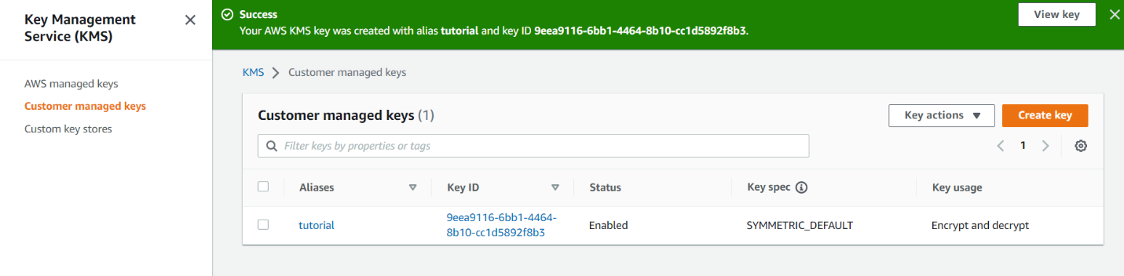

# 1) encryption

aws kms encrypt --key-id alias/tutorial --plaintext fileb://ExampleSecretFile.txt --output text --query CiphertextBlob  --region eu-west-2 > ExampleSecretFileEncrypted.base64

# base64 decode for Linux or Mac OS

cat ExampleSecretFileEncrypted.base64 | base64 --decode > ExampleSecretFileEncrypted

# base64 decode for Windows

certutil -decode .\ExampleSecretFileEncrypted.base64 .\ExampleSecretFileEncrypted

# 2) decryption

aws kms decrypt --ciphertext-blob fileb://ExampleSecretFileEncrypted   --output text --query Plaintext > ExampleFileDecrypted.base64  --region eu-west-2

# base64 decode for Linux or Mac OS

cat ExampleFileDecrypted.base64 | base64 --decode > ExampleFileDecrypted.txt

# base64 decode for Windows

certutil -decode .\ExampleFileDecrypted.base64 .\ExampleFileDecrypted.txt

**KMS AND LAMDA PRACTICE**

Create lambda

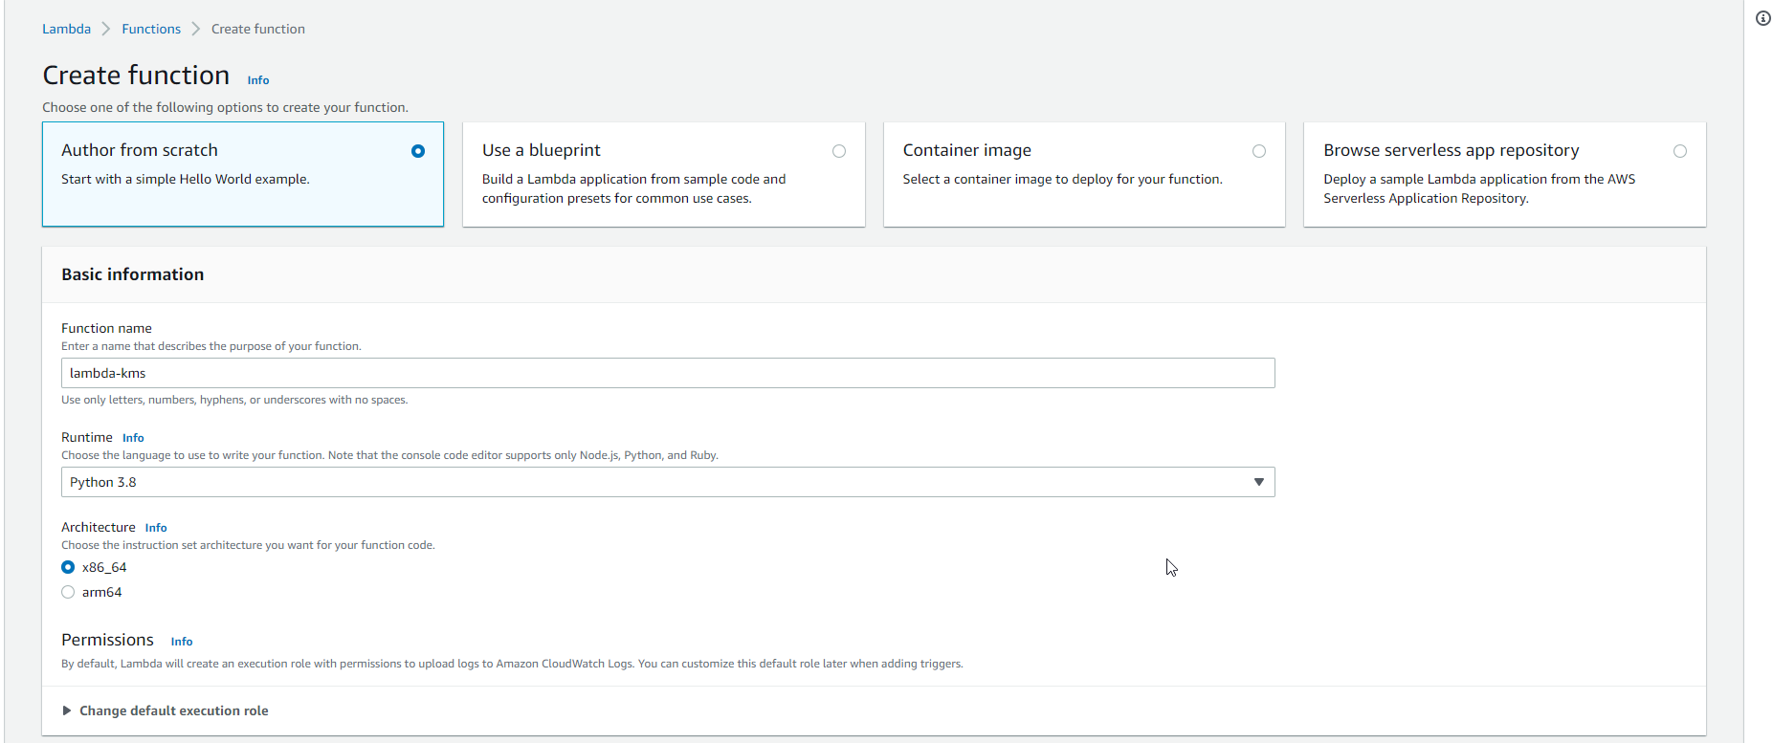

Go to configuration

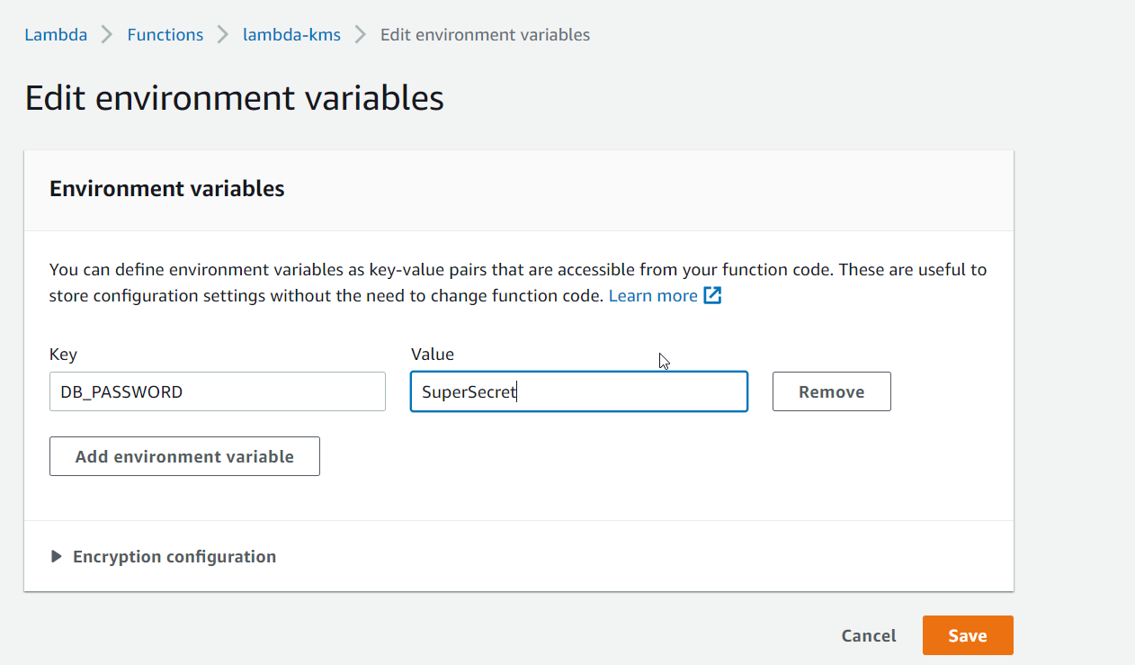

Same as

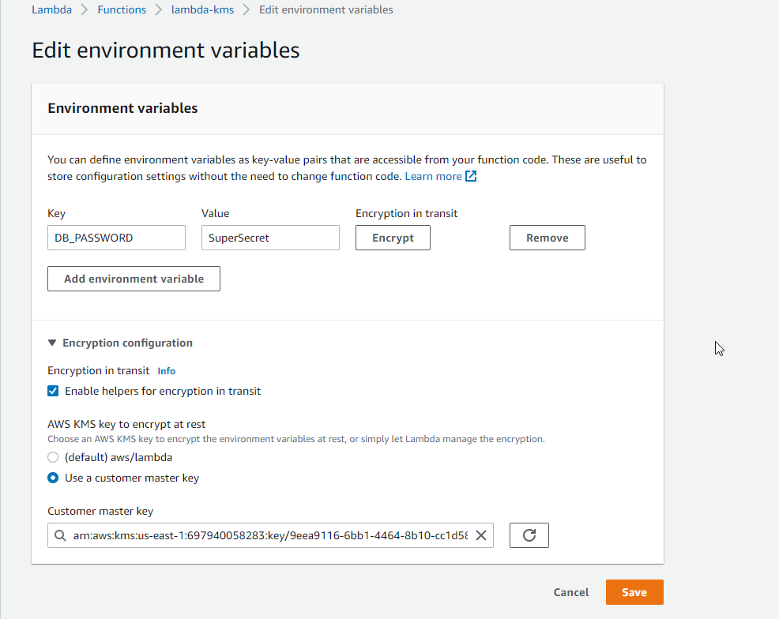

Click encrypt

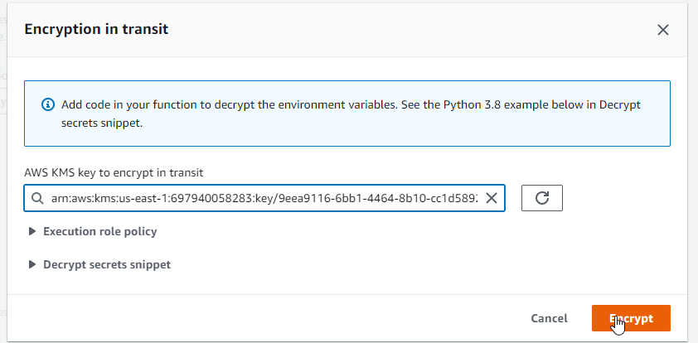

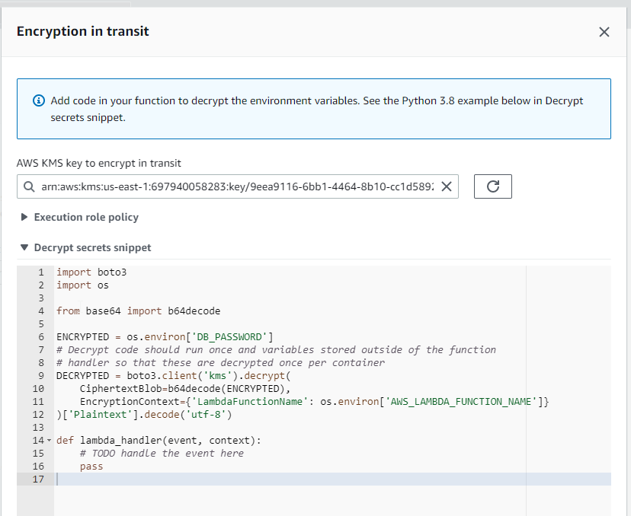

Paste and deploy and test on lambda

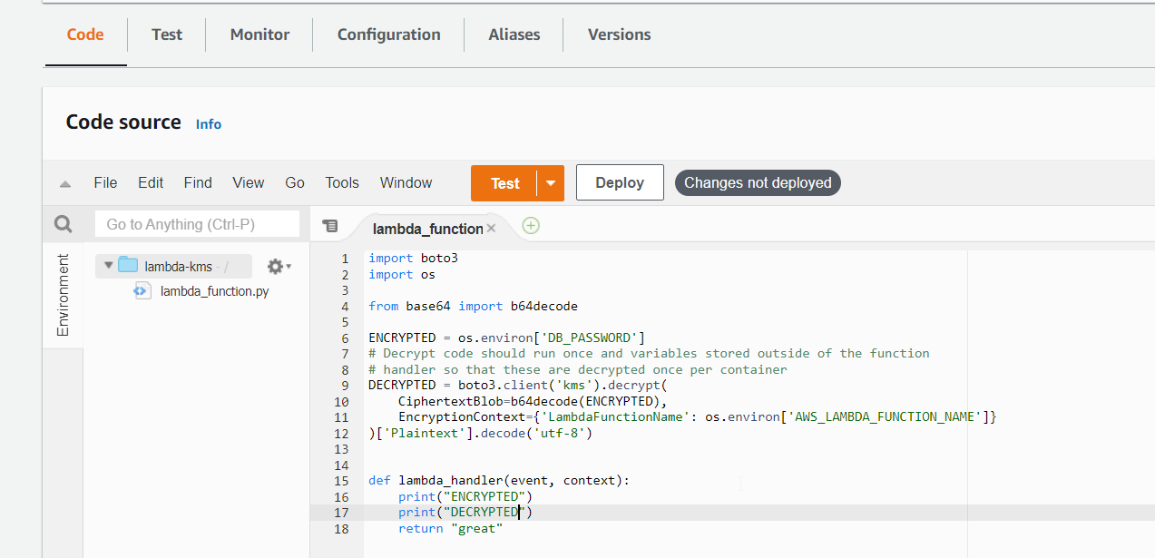

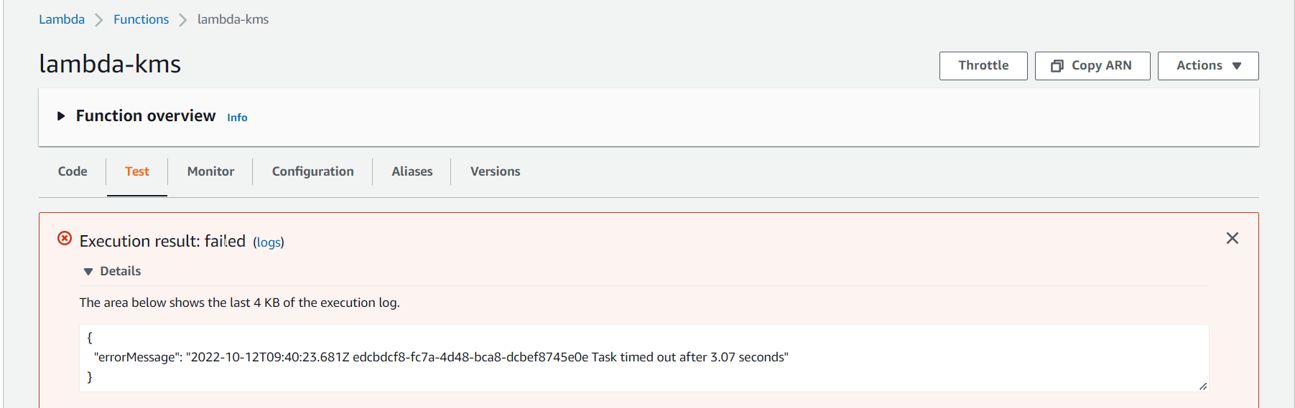

Go to configuration and general

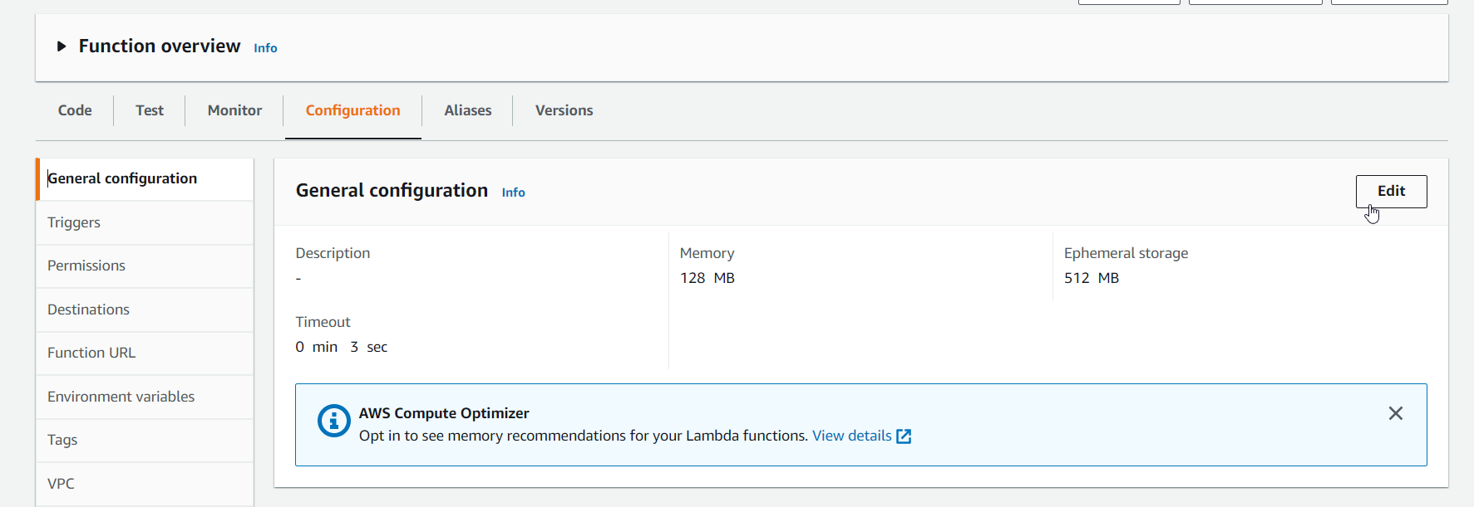

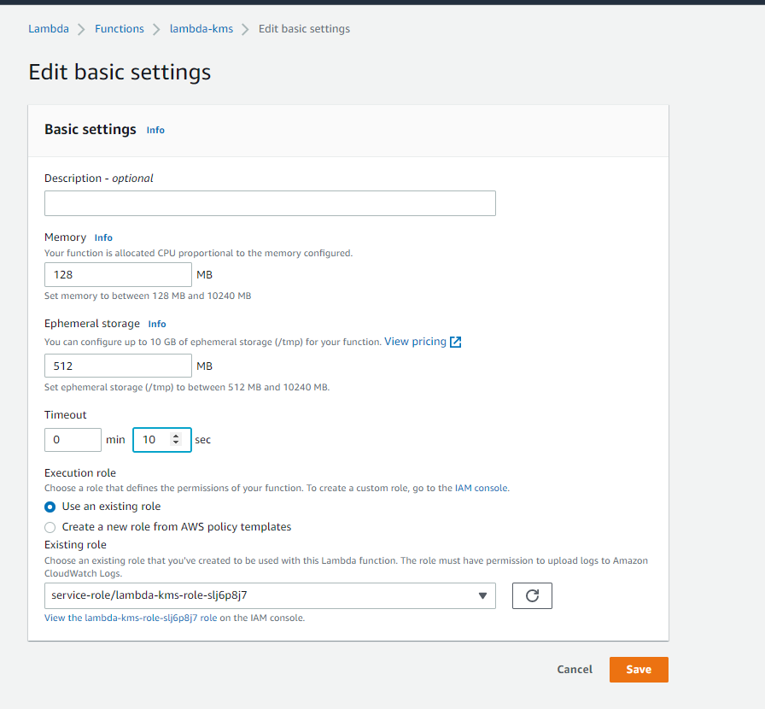

Again test our function

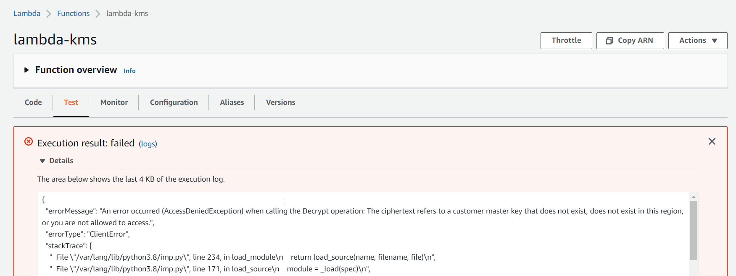

ADD IAM POLICY

KMS DECRYPT

Create inline policy

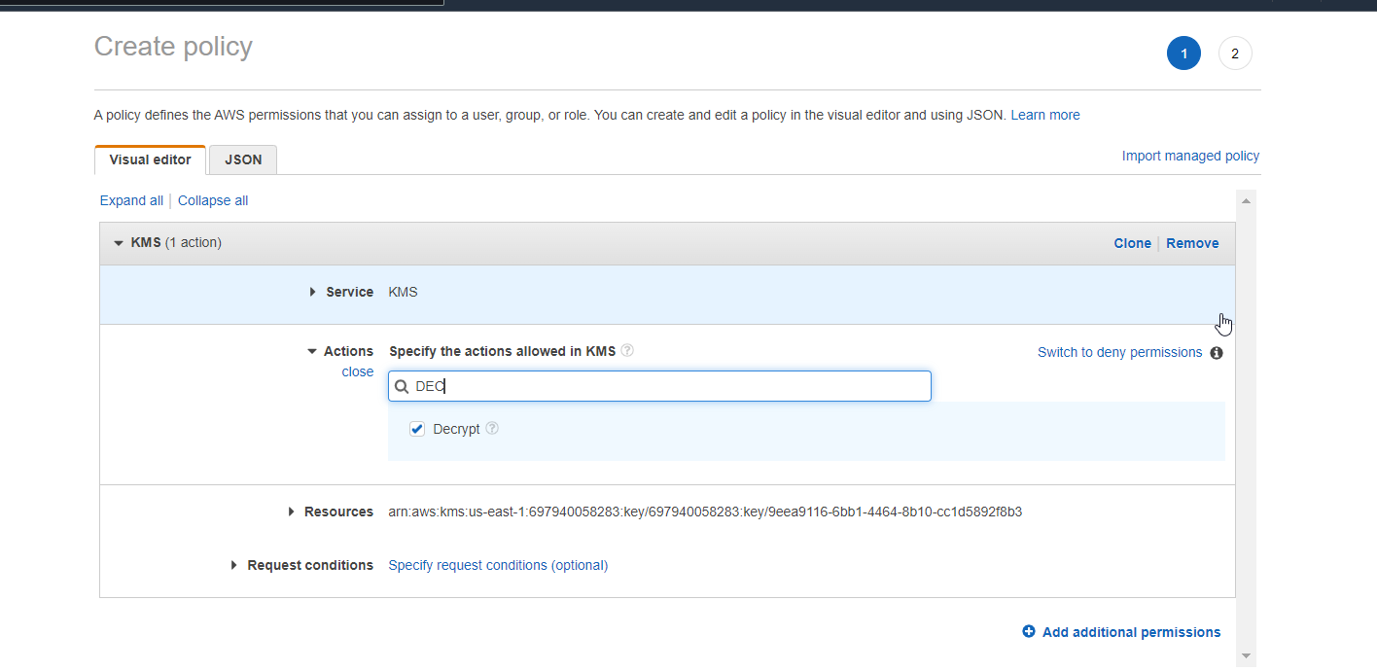

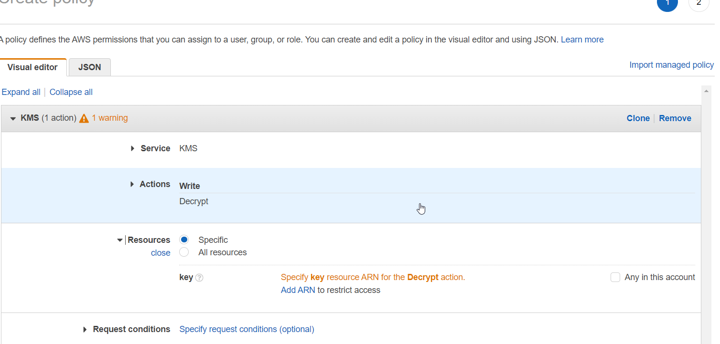

Copy arn key from KMS

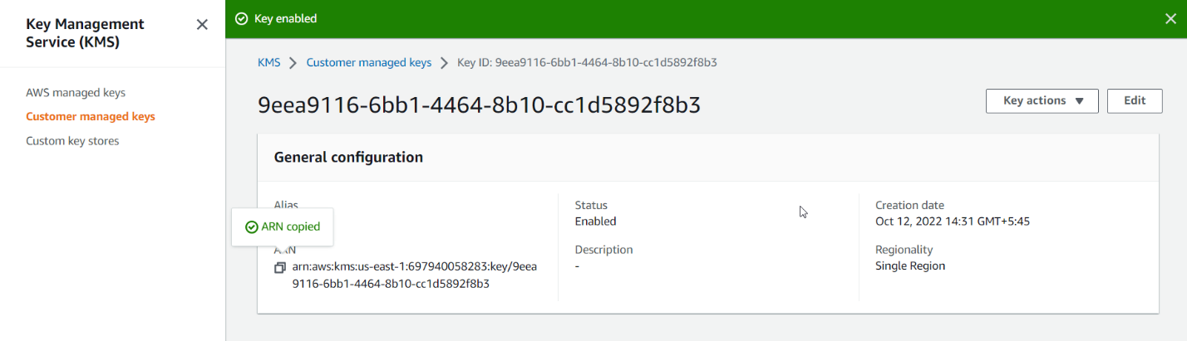

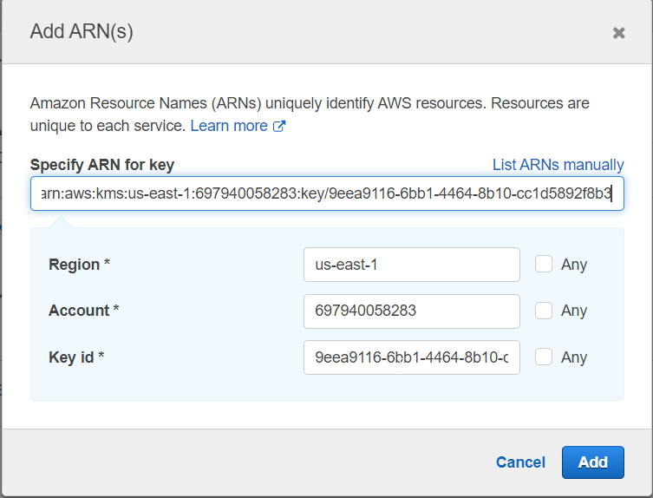

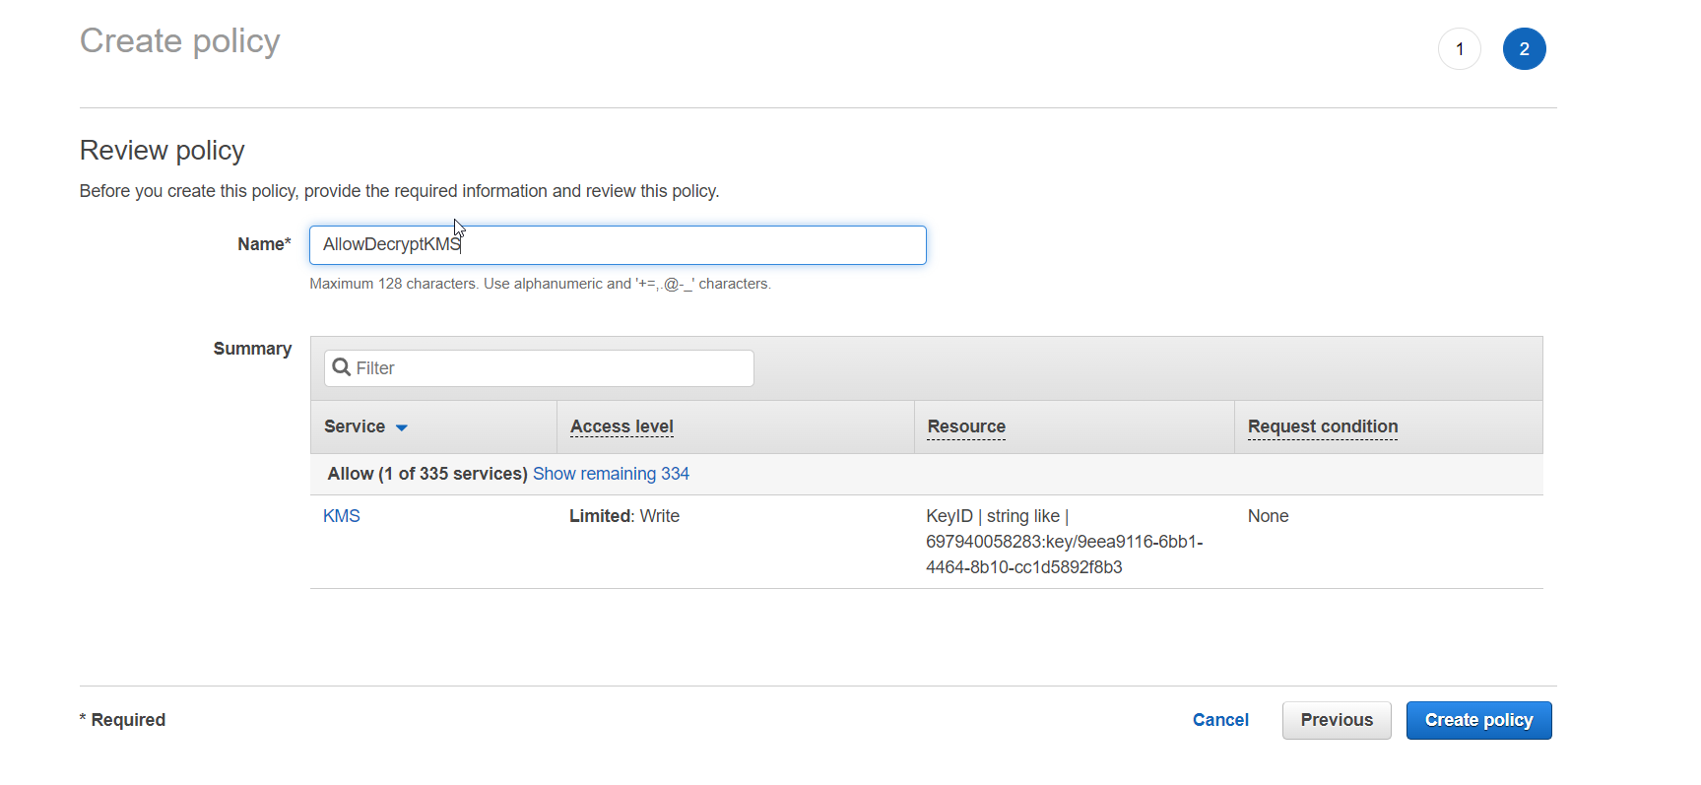

Go back to code and test

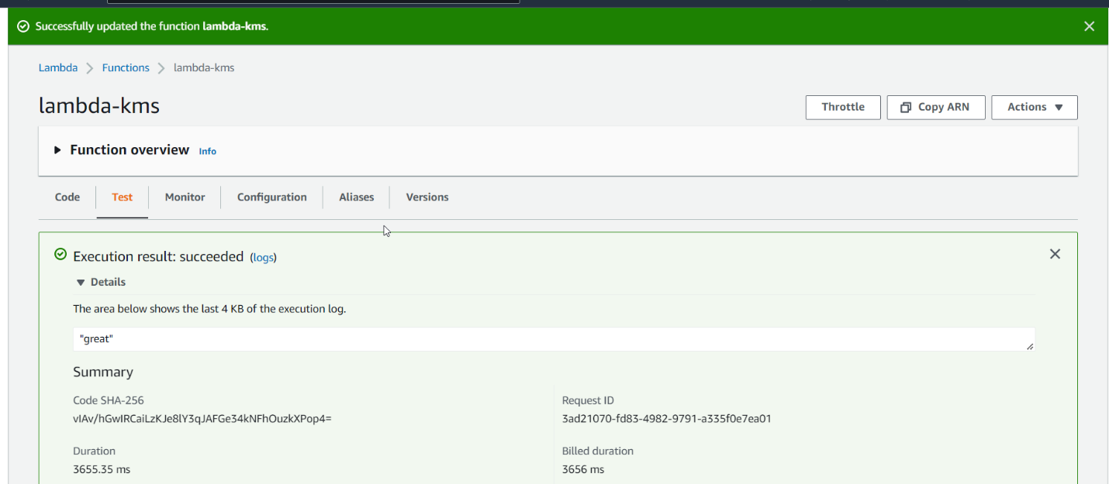

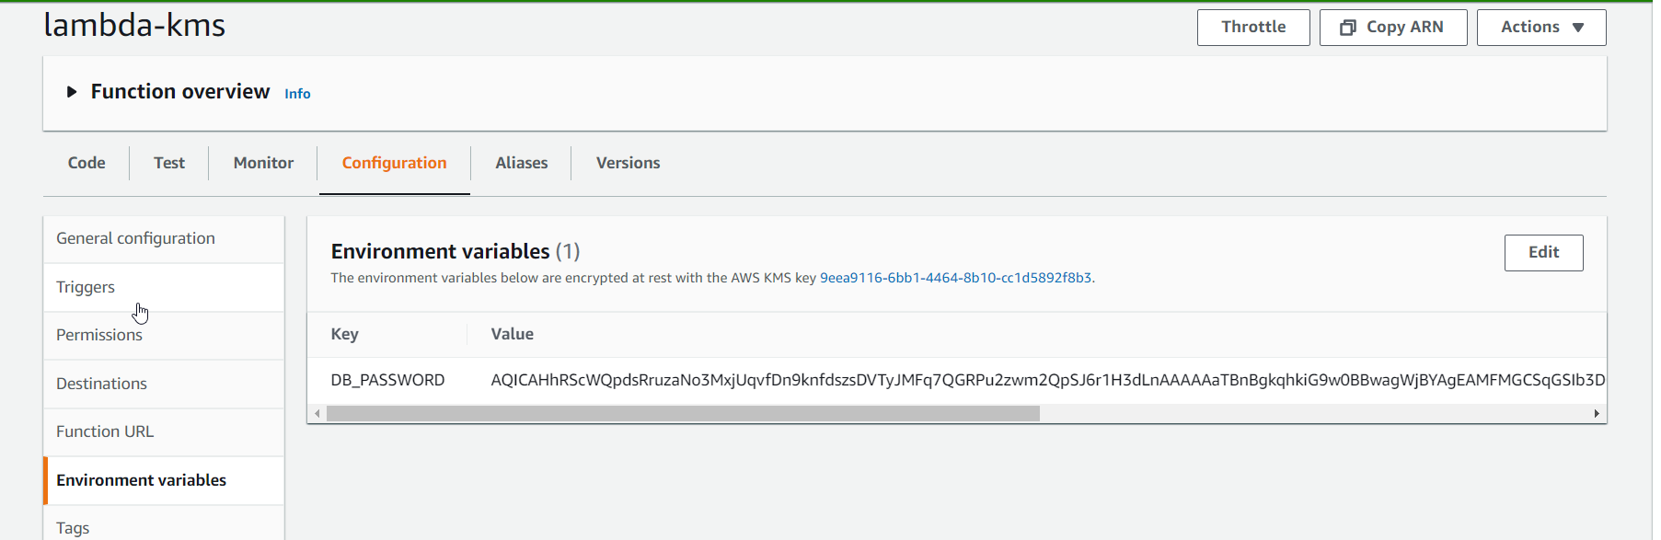

Ssm parameter

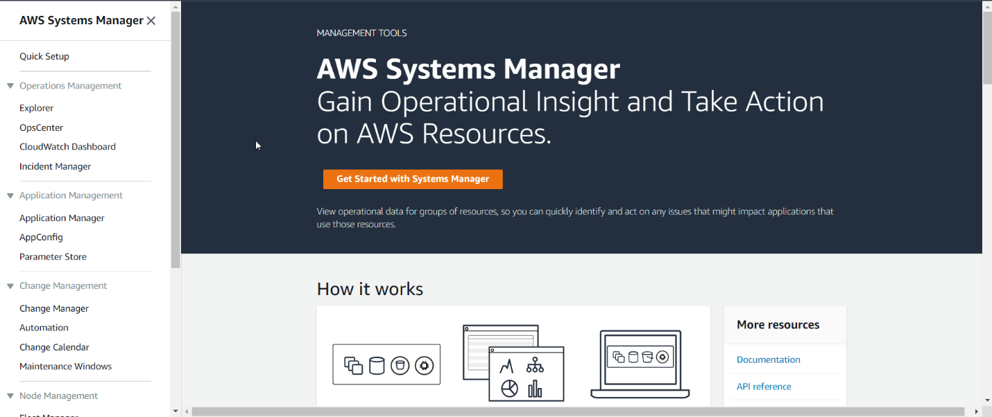

Click parameter store

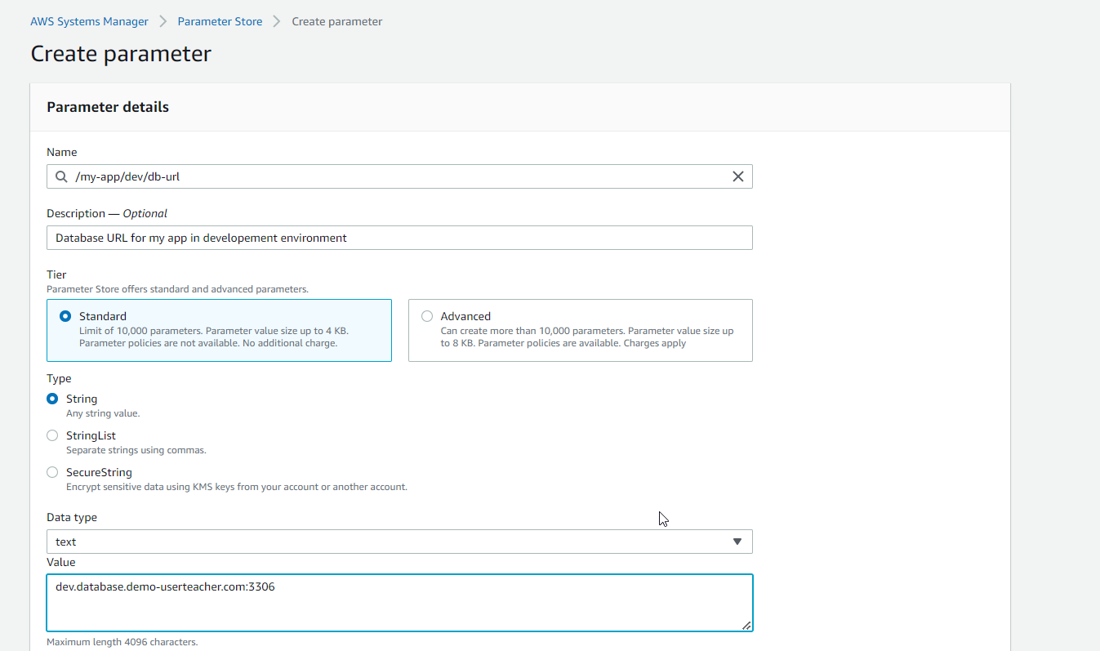

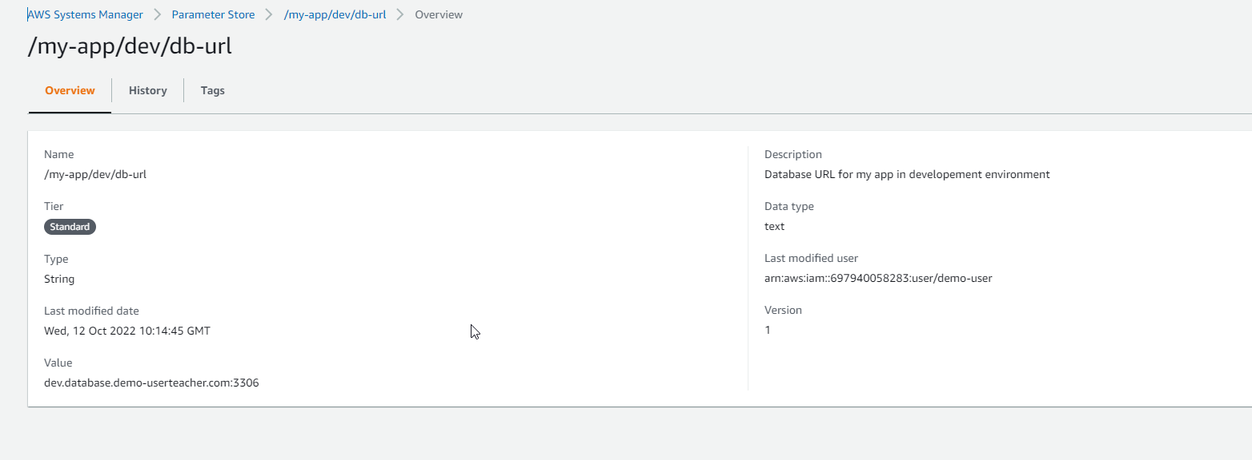

Create another parameter

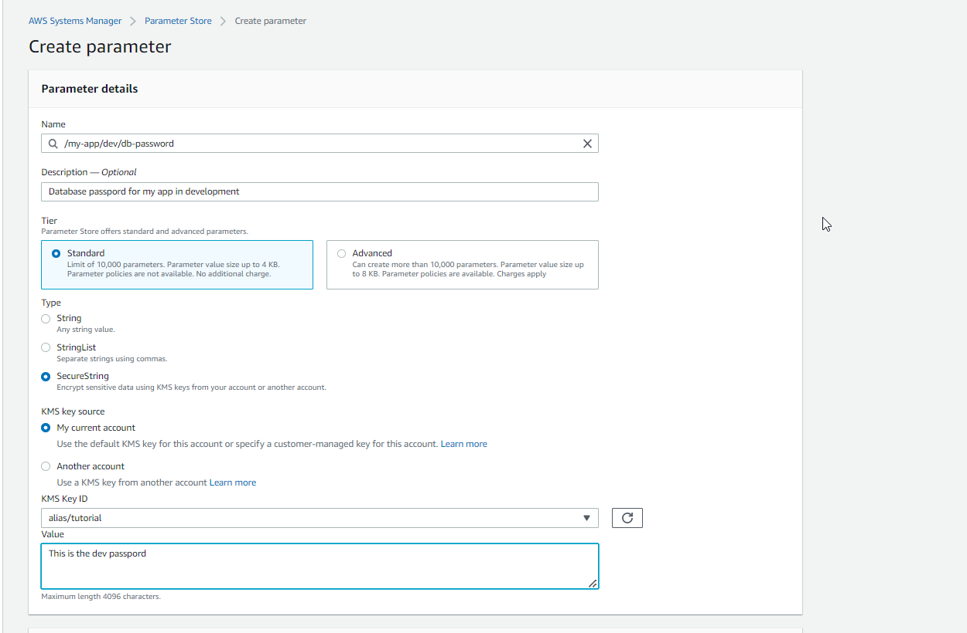

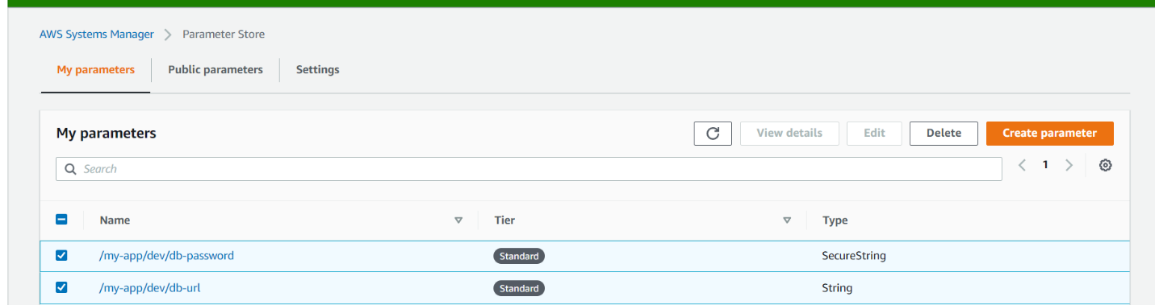

Create another parameter

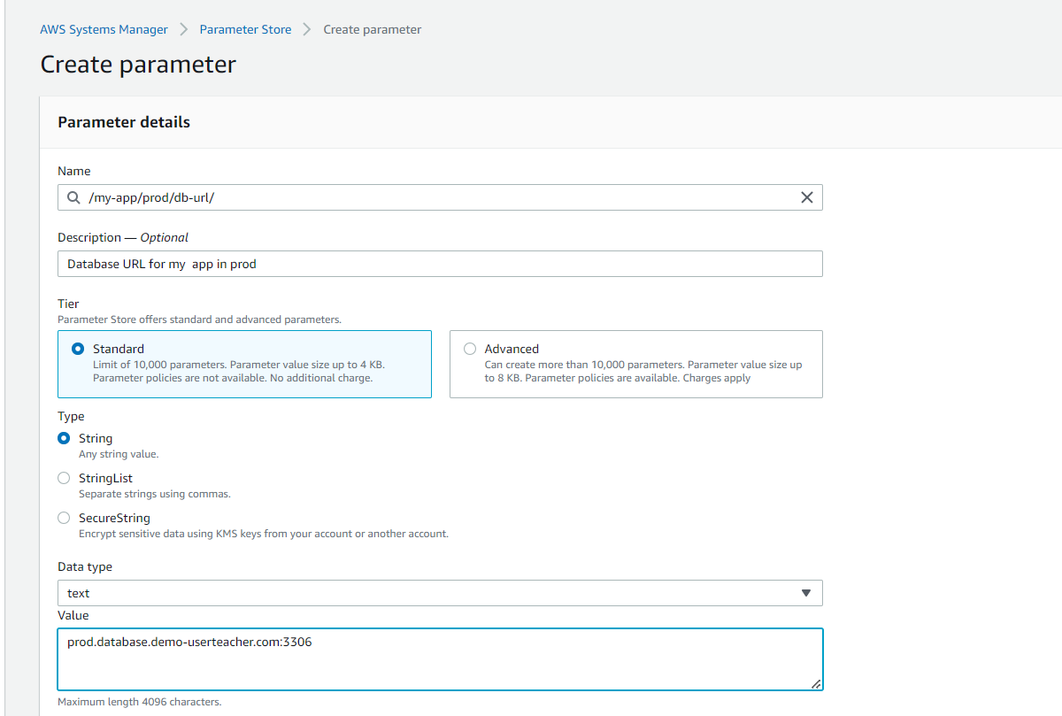

Create last parameter

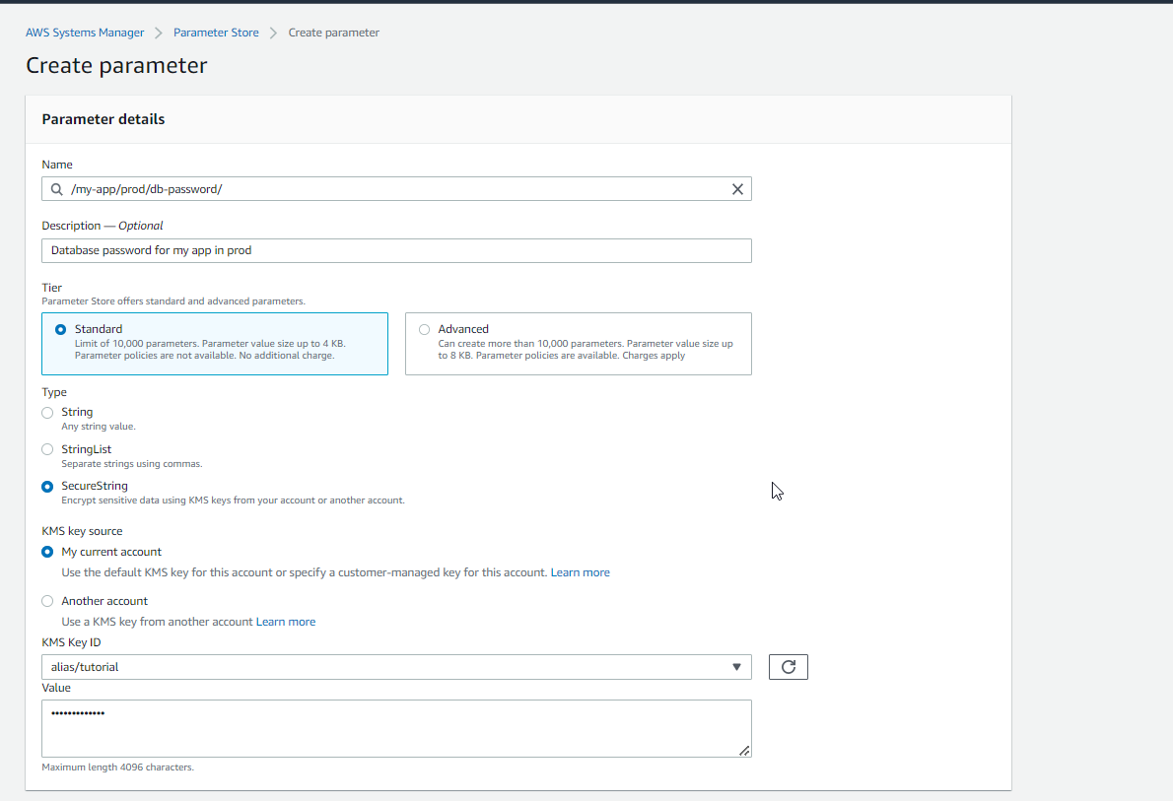

# GET PARAMETERS

aws ssm get-parameters --names /my-app/dev/db-url /my-app/dev/db-password

# GET PARAMETERS WITH DECRYPTION

aws ssm get-parameters --names /my-app/dev/db-url /my-app/dev/db-password --with-decryption

# GET PARAMETERS BY PATH

aws ssm get-parameters-by-path --path /my-app/dev/

# GET PARAMETERS BY PATH RECURSIVE

aws ssm get-parameters-by-path --path /my-app/ --recursive

# GET PARAMETERS BY PATH WITH DECRYPTION

aws ssm get-parameters-by-path --path /my-app/ --recursive --with-decryption

SSM parameter on Lambda

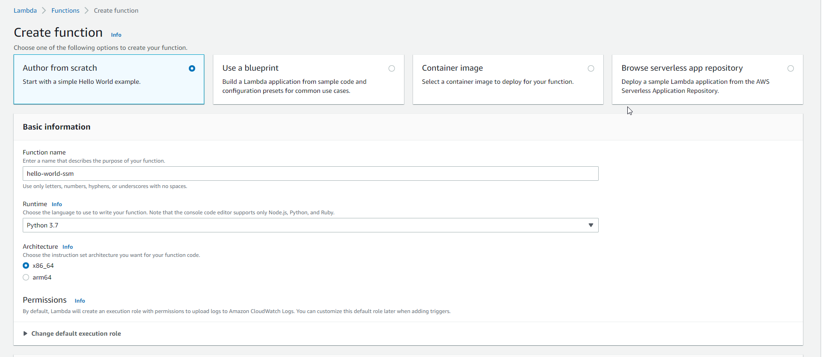

Lambda error

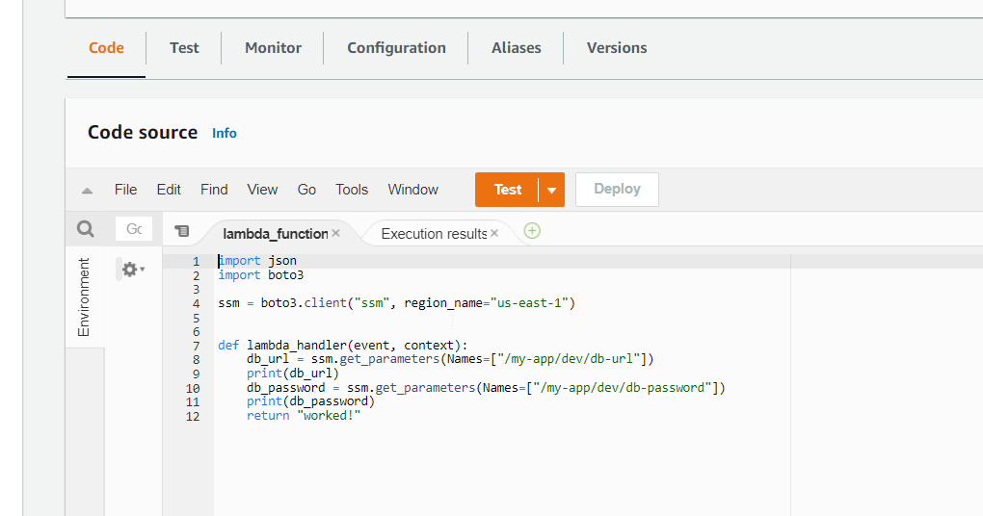

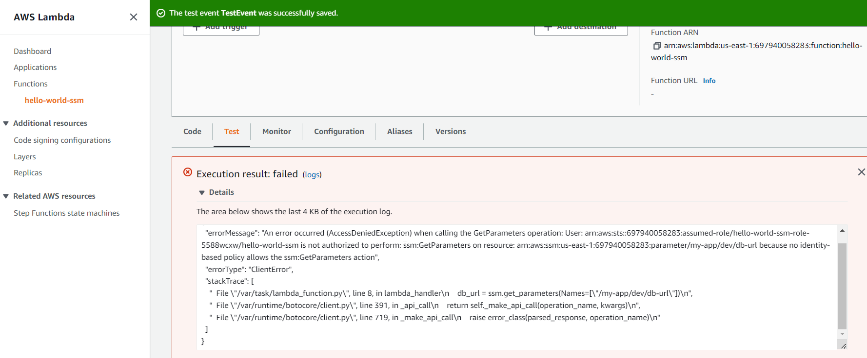

ADD IAM ROLE

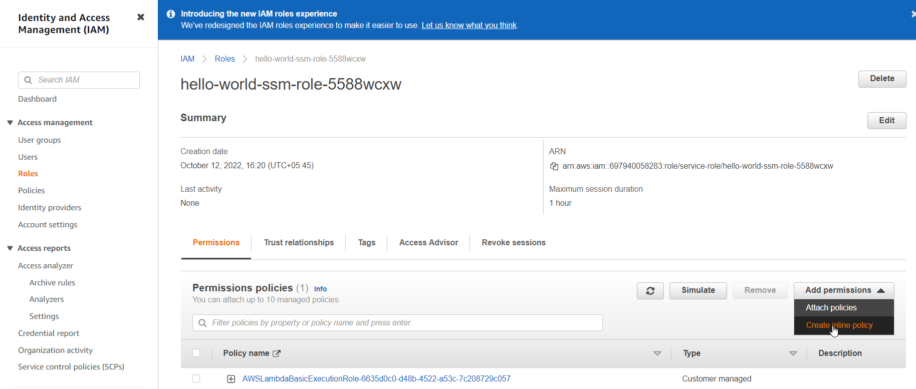

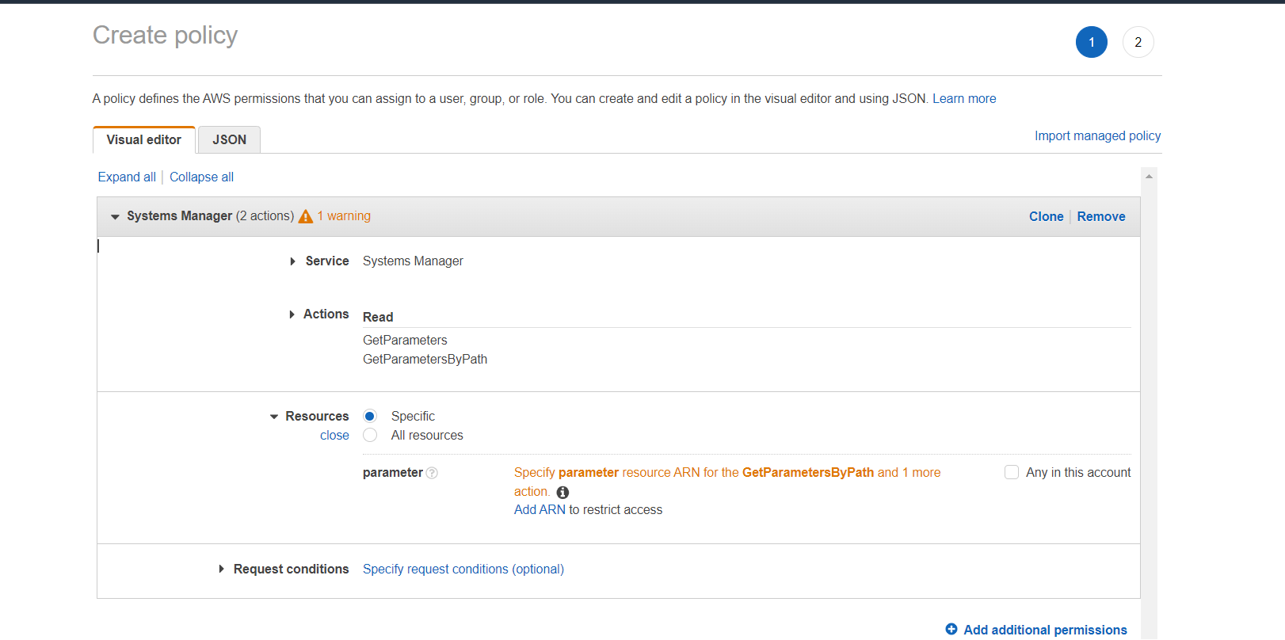

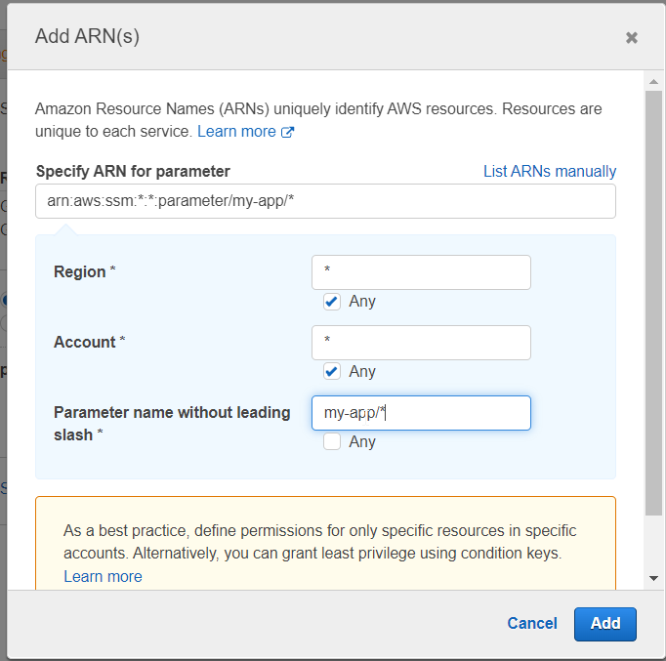

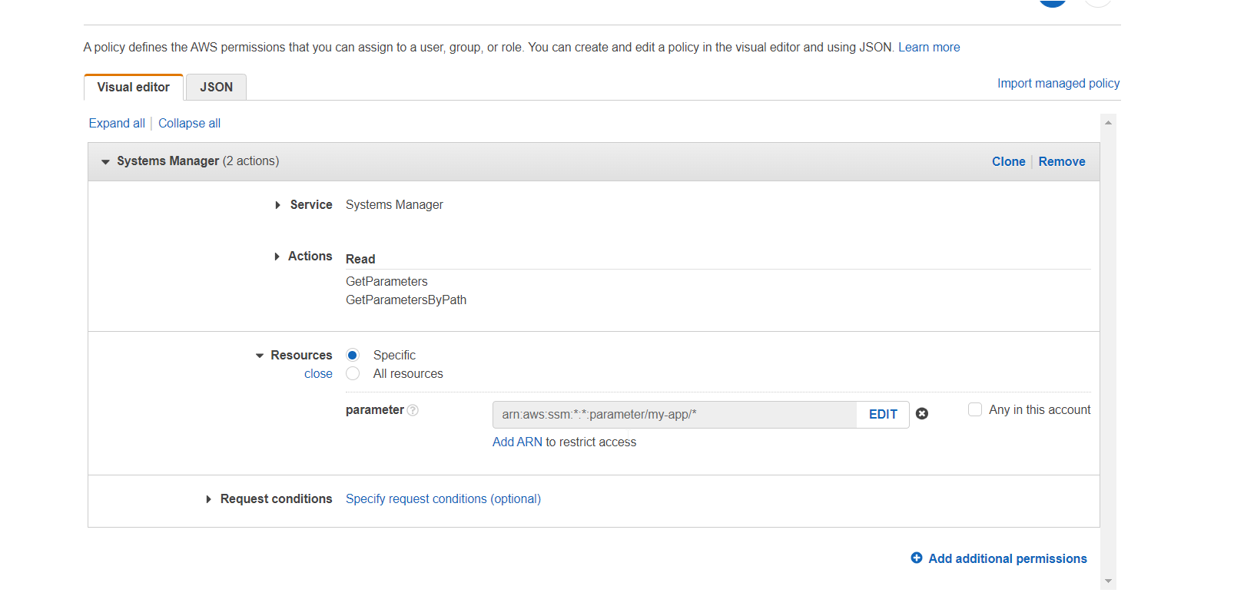

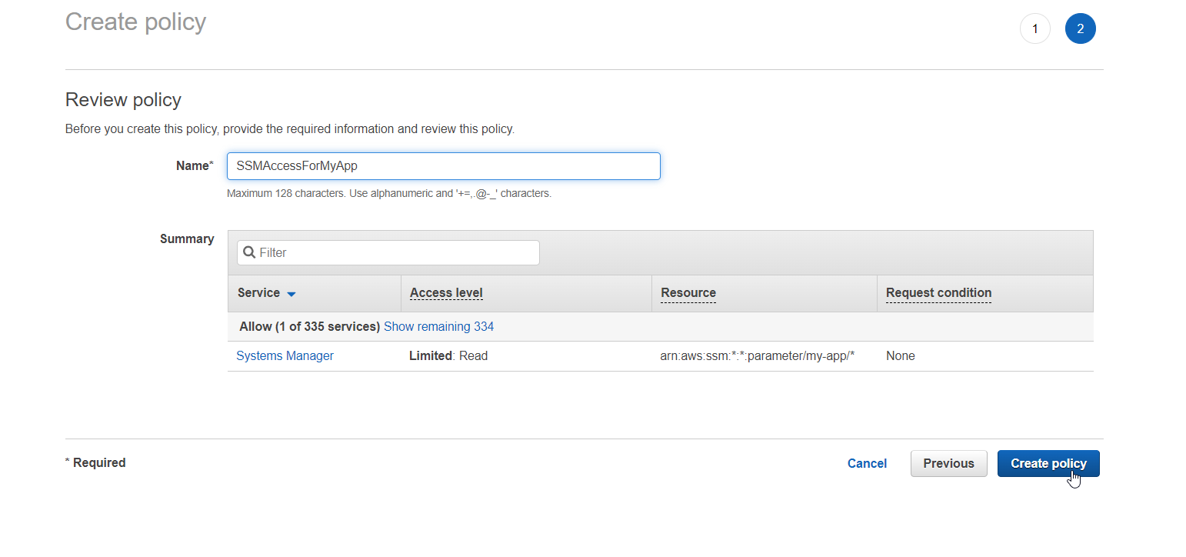

Go to lambda and test

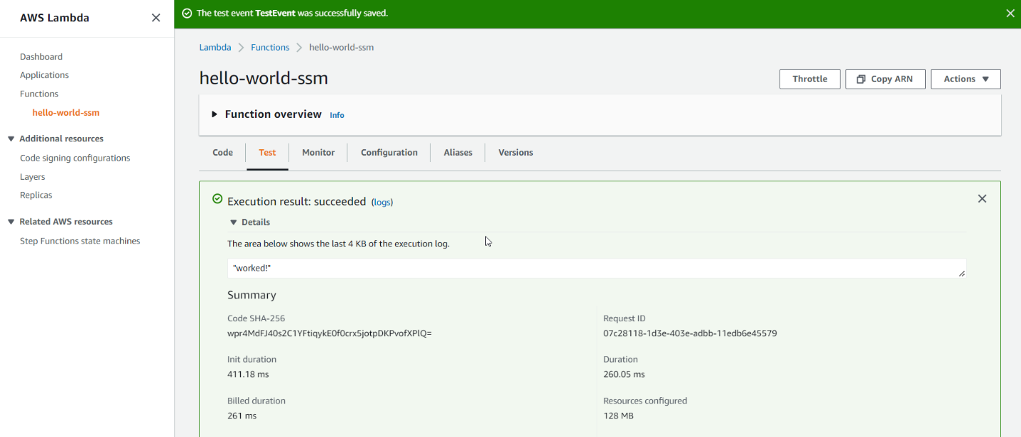

Run following code

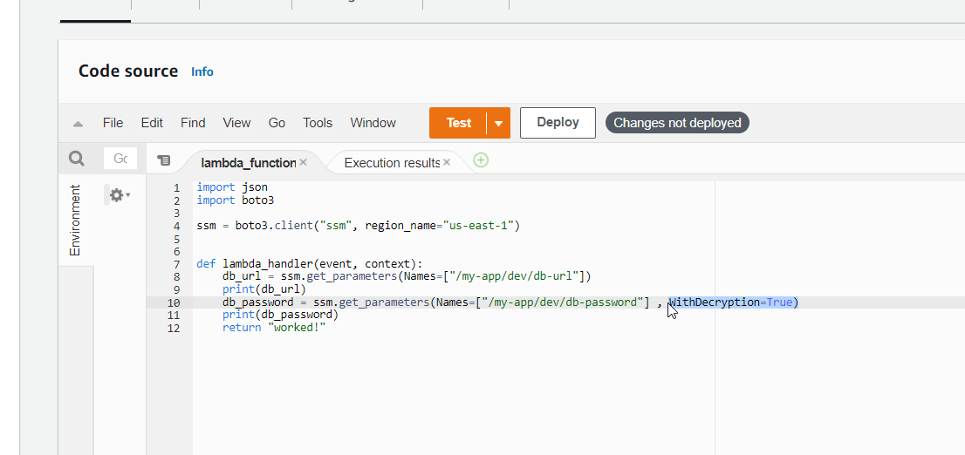

I got this error

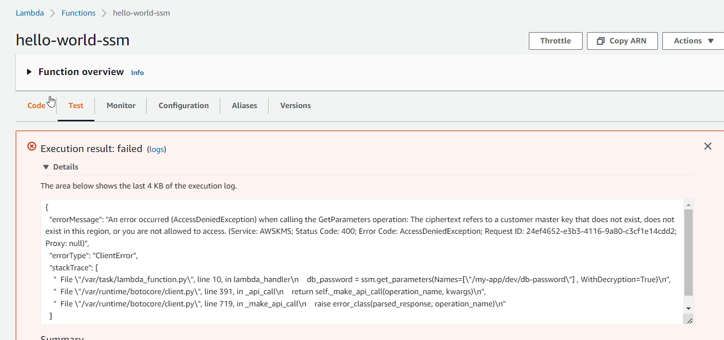

Go to IAM ATTACH KMS WRITE DECRYPT

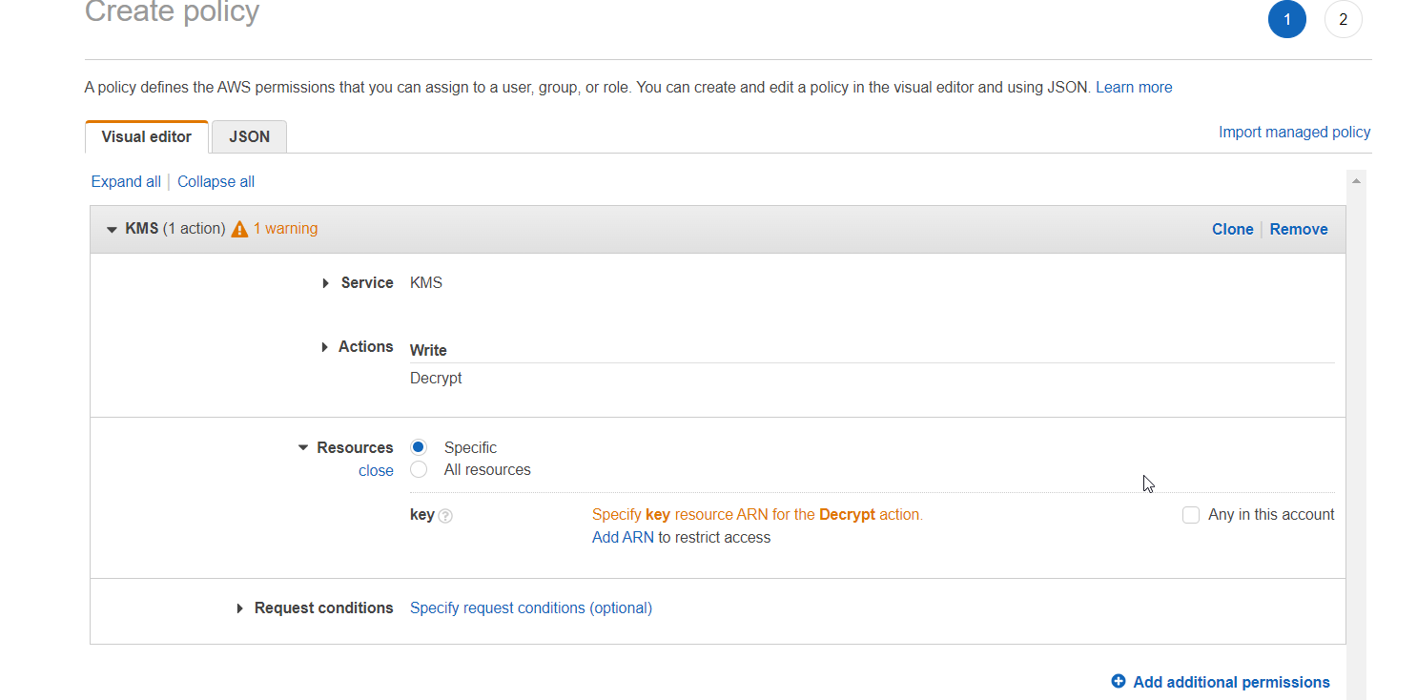

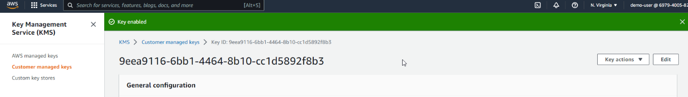

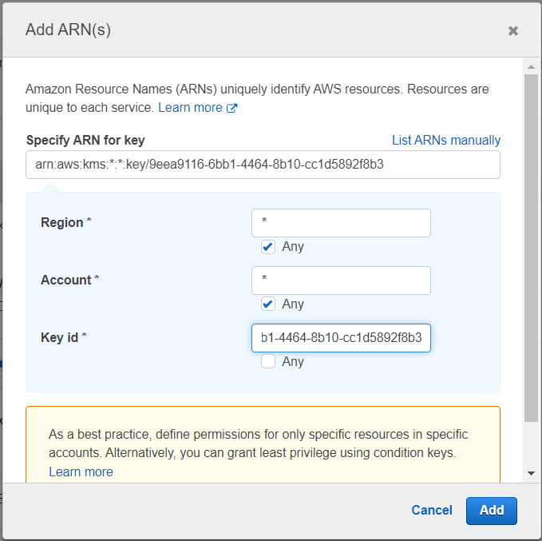

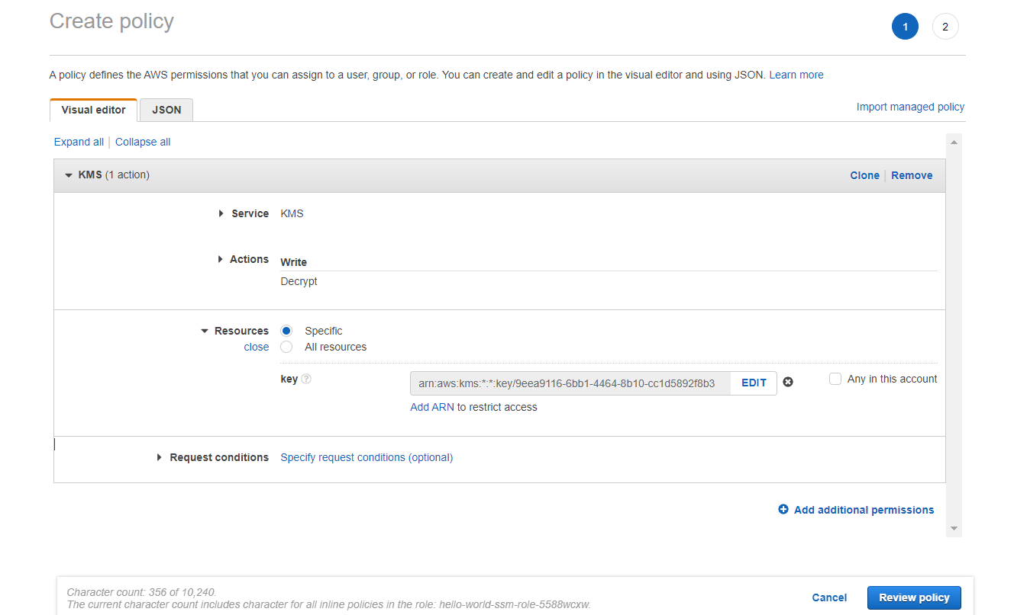

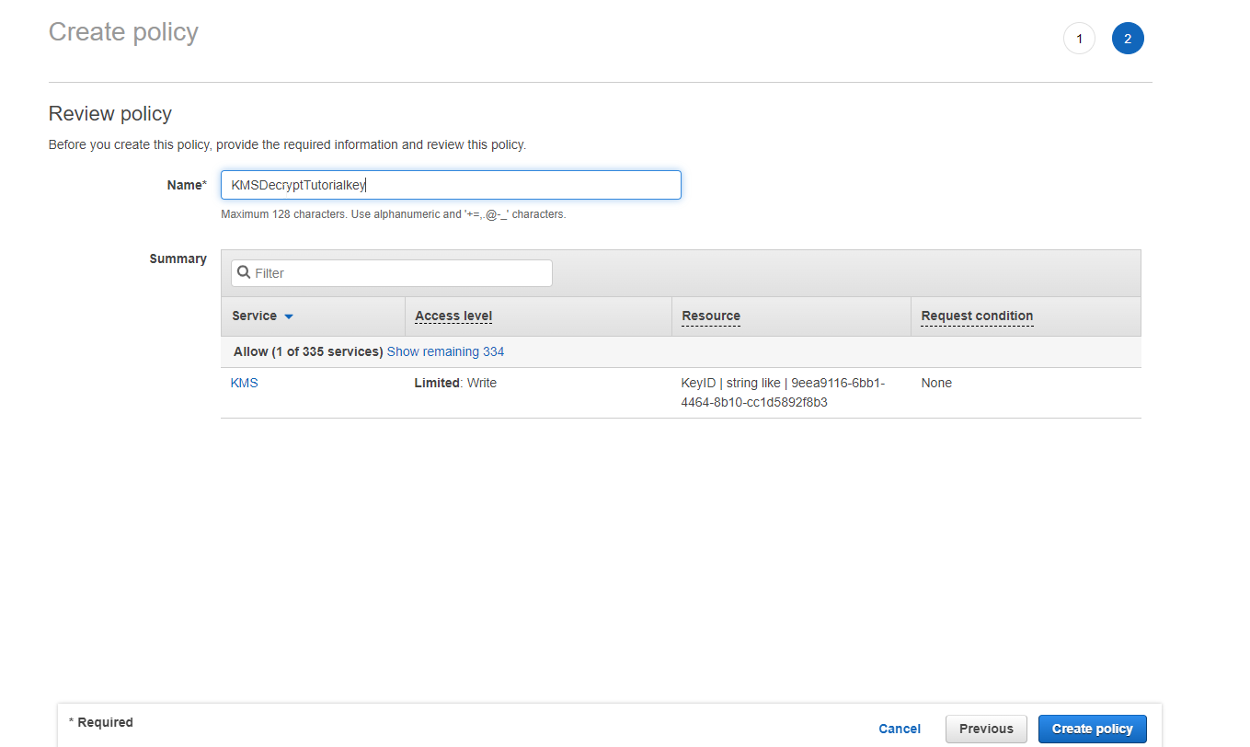

Now it works

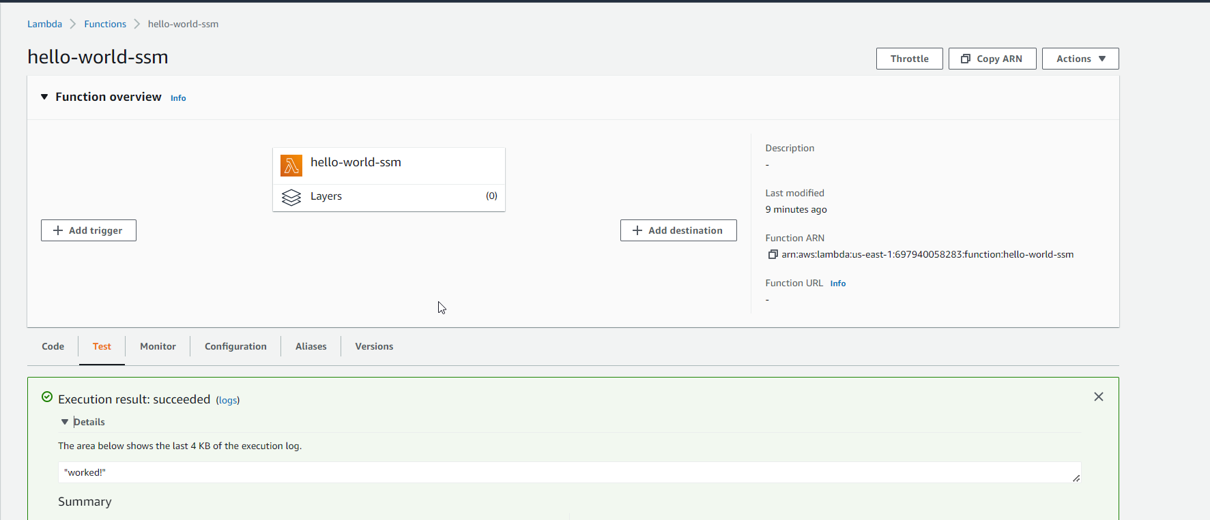

Go to environment6 variable

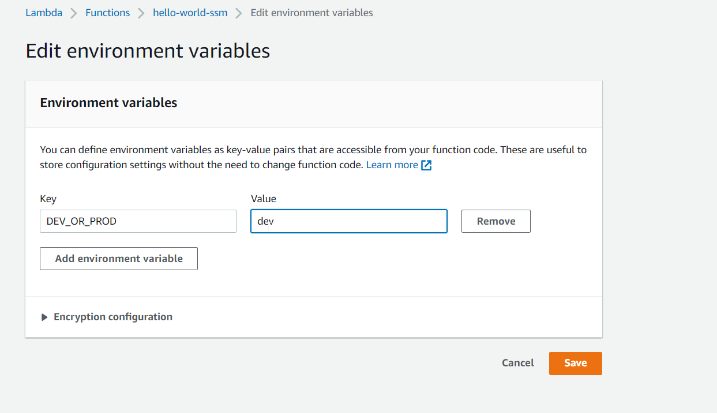

import json

import boto3

import os

ssm = boto3.client('ssm', region_name="us-east-1")

dev_or_prod = os.environ['DEV_OR_PROD']

def lambda_handler(event, context):

    db_url = ssm.get_parameters(Names=["/my-app/dev/db-url" + dev_or_prod + "/db-url"])

    print(db_url)

    db_password = ssm.get_parameters(Names=["/my-app/dev/db-password" + dev_or_prod + "/db-password"], WithDecryption=True)

    print(db_password)

    return "worked!"

now

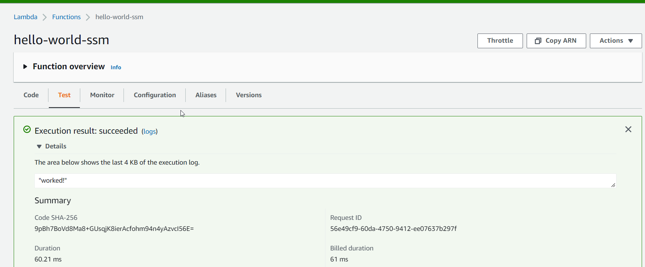

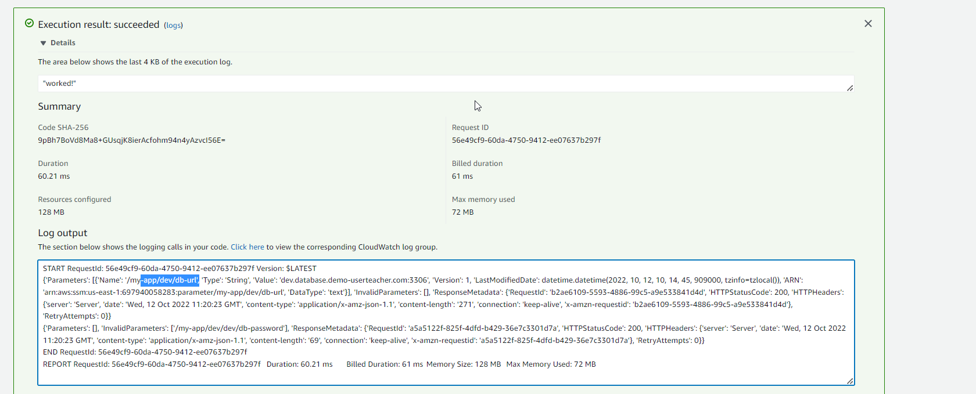

Again if we changed environment variable

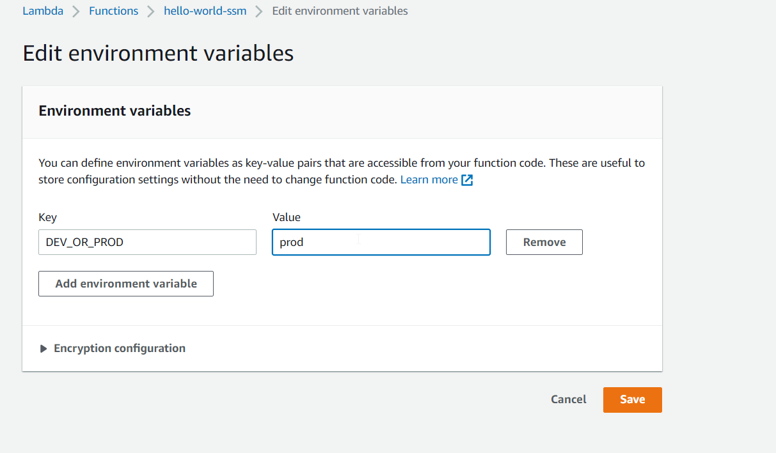

We get prod

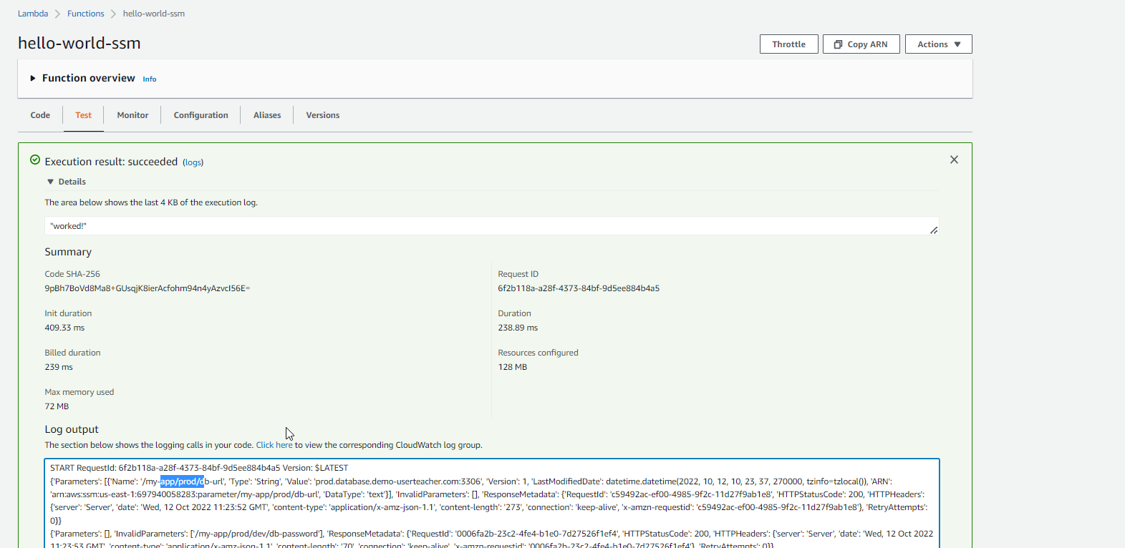

Secret manager

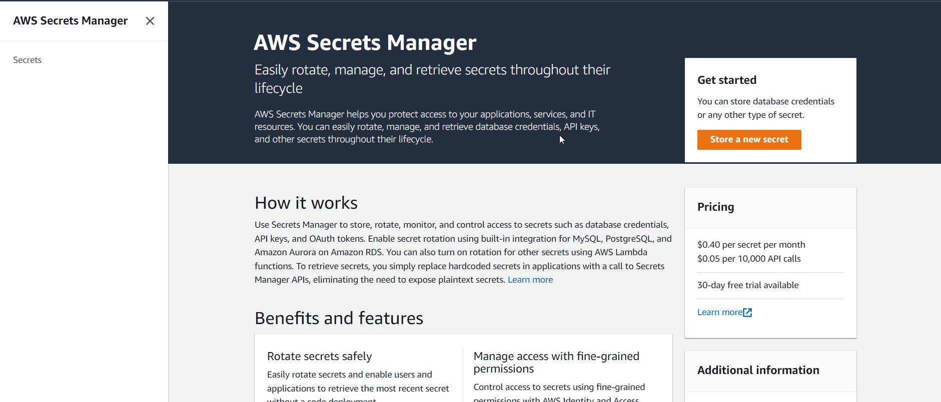

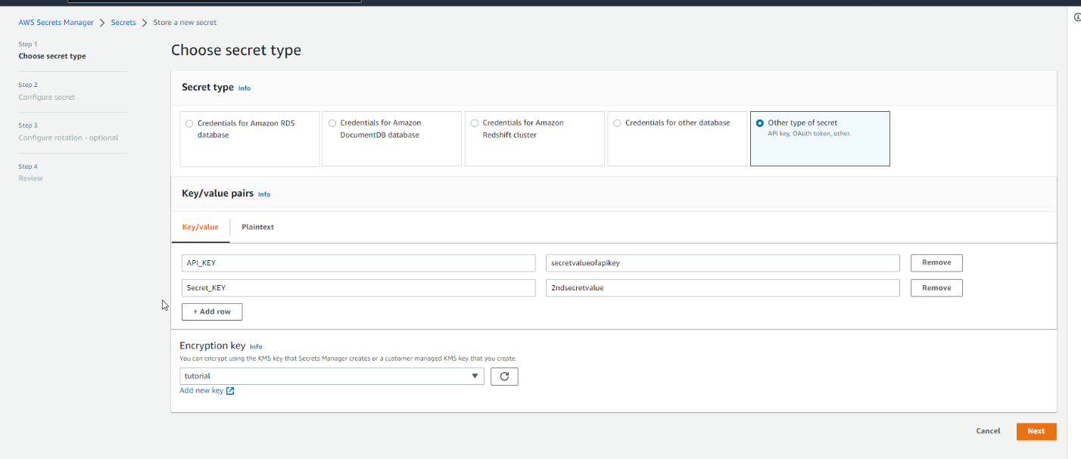

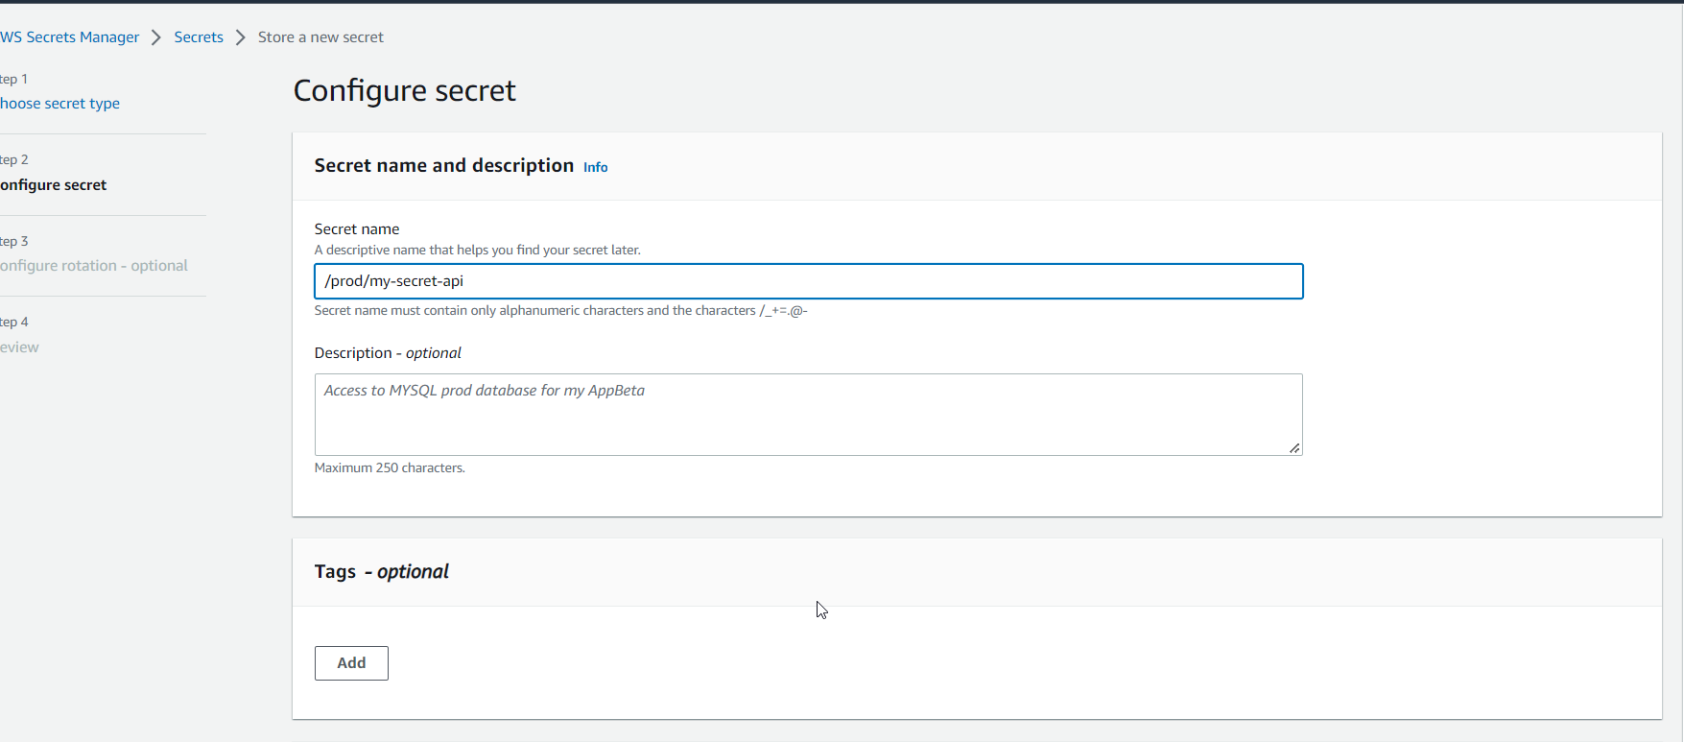

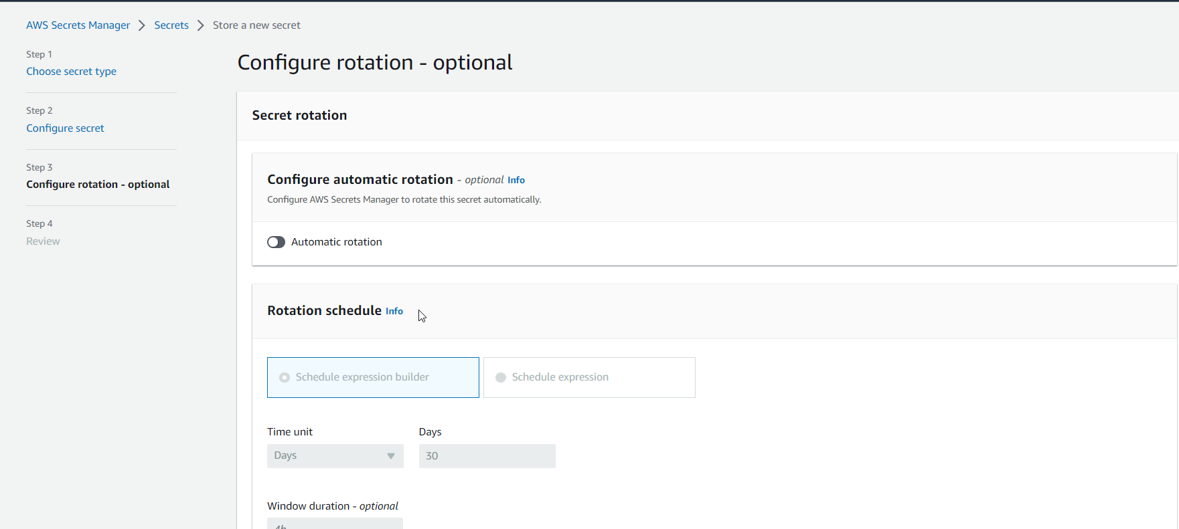

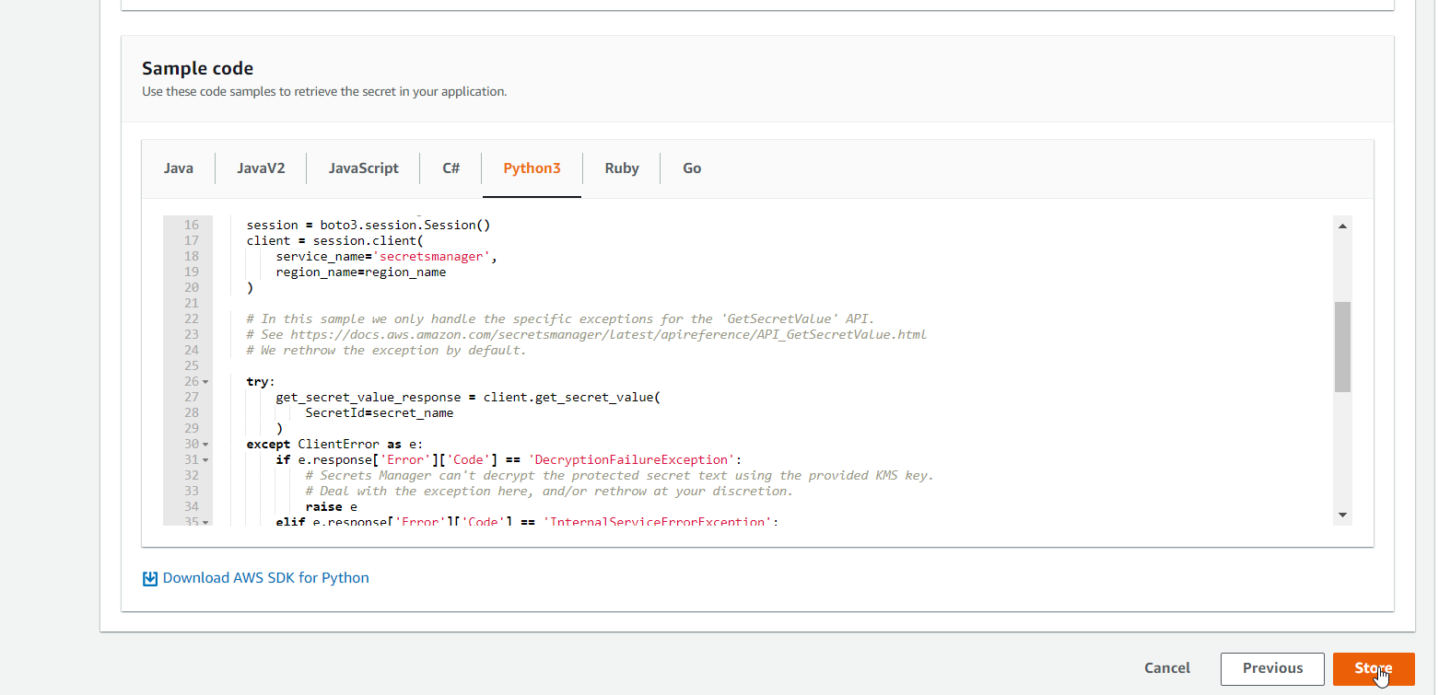

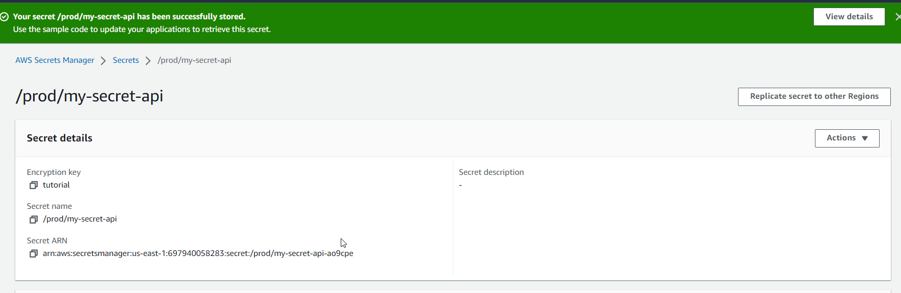

Clean up

